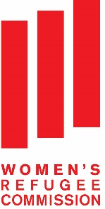

Strengthening Networks of Women with Disabilities on Humanitarian Issues

Project Overview

The Women’s Refugee Commission (WRC) improves the lives and protects the rights of women, children and youth displaced by crisis and conflict, including those with disabilities. We identify needs, identify solutions and advocate for policies to improve access and inclusion for persons with disabilities in humanitarian programs.
The WRC’s Strengthening Networks of Women with Disabilities on Humanitarian Issues project supports the leadership of women with disabilities to advocate on humanitarian issues at national, regional and global levels. This project is supported by UN Women and the Australian government.

Background
An estimated 9 million persons with disabilities are forcibly displaced worldwide as a result of persecution, conflict and generalized violence. They are among the most vulnerable and socially excluded groups in any refugee and displaced community. They are not identified in data collection or included in needs assessments, and thus not considered in program design or implementation.
Increasingly, women with disabilities are understood to experience “double discrimination” on the basis of their gender and disability. This discrimination is exacerbated in conflict and displacement situations, where they face a variety of human rights violations, including violence, abuse and exploitation.
The Convention on the Rights of Persons with Disabilities (CRPD) requires that states parties “ensure that protection services are age-, gender- and disability-sensitive” (Article 16). Increasingly, global discussions on humanitarian action have centered around finding better ways to meet the needs of people affected by conflict and disasters. Promoting the rights of women and girls most at risk, including those with disabilities, is central to this discussion. Women-led, community-based organizations, such as organizations of women with disabilities, can play a critical role to ensure this happens. For example, these women’s organizations can participate in the development of standards, guidelines and coordination forums at global, regional and national levels and thus ensure humanitarian stakeholders are more accountable. Initial consultations by the WRC with organizations of women with disabilities highlighted the need to expand and strengthen knowledge, networking and alliances in order for them to meaningfully engage in humanitarian processes at global, regional and national levels.
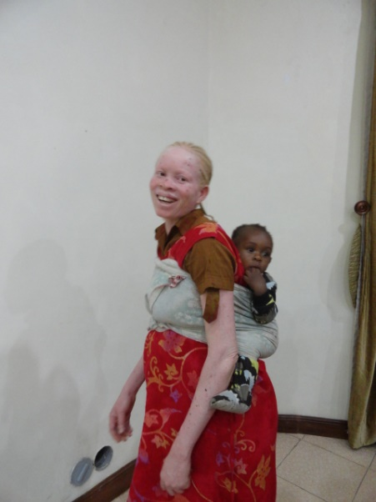

About the Project
Working in partnership with regional networks of women with disabilities, including the Network of African Women with Disabilities (NAWWD) and the South Asia Disability and Development Initiative (SADDI), this one-year project will increase the capacity of networks of women with disabilities to advocate for the inclusion of women and girls with disabilities affected by humanitarian crisis in national, regional and global forums.
This will be achieved through the following activities:
A global mapping. The WRC will research positive practices, gaps and opportunities for inclusion of women and girls with disabilities in humanitarian and post-conflict programming. Furthermore, we will document the role of women’s organizations with disabilities in humanitarian responses, identifying opportunities and capacity development goals. We will draw up recommendations for humanitarian, disability and women’s rights actors on inclusion and empowerment of women and girls with disabilities in humanitarian and post-conflict programs.
Training on humanitarian issues for organizations of women with disabilities. We will design and pilot a training module on humanitarian issues for organizations of women with disabilities, which will be disseminated and integrated into leadership trainings for women with disabilities.
Regional workshops for organizations of women with disabilities. The WRC will support partners in Africa and South Asia to conduct regional training and action-planning workshops for women with disabilities on humanitarian issues. At these forums, women with disabilities will exchange information and ideas, build new alliances with humanitarian and women’s rights actors, and develop collaborative advocacy plans on humanitarian issues.
Advocacy for global policy and practice change. Finally, the project will bring together regional networks of women with disabilities together in global forums, such as the World Humanitarian Summit, the Conference of State Parties to the Convention on the Rights of Persons with Disabilities or the Commission on the Status of Women, where they can collaboratively advocate for the inclusion of women and girls with disabilities in humanitarian action. The WRC, with our partners, will conduct policy briefings and other awareness-raising events for UN agencies, NGOs, donors and other key groups, presenting project findings and materials, and fostering support and commitment to project recommendations.
Through these activities, the WRC anticipates positive progress toward our wider program goal: that the issues of women and girls with disabilities will be increasingly reflected in global humanitarian policy and practice.
We will work with partners to monitor change in knowledge, attitudes and practices related to humanitarian advocacy among women with disabilities. The WRC will also document “Stories of Change” from women’s representatives with disabilities to identify the impact of their change in capacity, putting their perspectives and voices at the center of evaluation. These Stories of Change, shared with other networks, relevant stakeholders and audiences, will also serve as valuable advocacy tools for women’s organizations with disabilities.

Contact:
Emma Pearce, Senior Disability Program Officer, EmmaP@wrcommission.org
Boram Lee, Disability Program Officer, BoramL@wrcommission.org

Women’s Refugee Commission, 122 East 42nd Street, New York, NY 10168-1289
Tel: 212.551.3115, email: info@wrcommission.org, www.womensrefugeecommission.org

January 2016

This figure is based on global estimates that 15 percent of the 60 million people forcibly displaced world-wide as a result of persecution, conflict, generalized violence and human rights violations may be persons with disabilities.
http://www.ohchr.org/Documents/HRBodies/HRCouncil/RegularSession/Session20/A-HRC-20-5_en.pdf and http://www.hrw.org/reports/2010/08/24/if-we-weren-t-human
United Nations (2006), Convention on the Rights of Persons with Disabilities, http://www.un.org/disabilities/default.asp?navid=14&pid=150
These findings are based on WRC consultations with women DPO leaders from the Network of African Women with Disabilities and the National Forum of Women with Disabilities in Pakistan, which is currently supporting leadership training for women with disabilities across the South Asia region.

