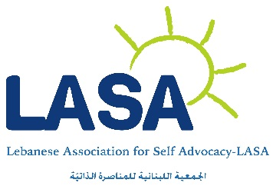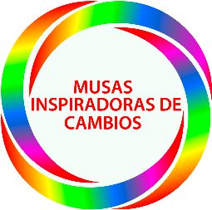

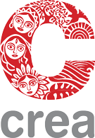

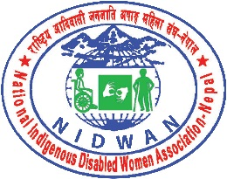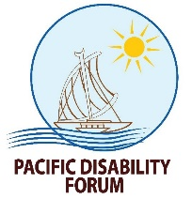

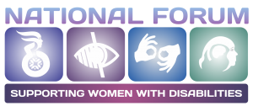

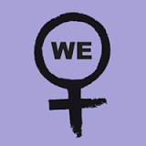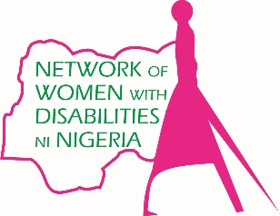

**Funding a diverse movement – How to engage women with disabilities**

**Recommendations from organizations of women with disabilities**

Women and girls with disabilities, an estimated 19.2% of the female population,[1] continue to face exclusion within both the disability and women’s rights movements. The contributions and expertise of organizations of women with disabilities, particularly those from resource limited countries, are yet to be fully realized in the women’s rights movement, as these organizations face a vicious cycle of lack of funding, which in turn impacts their organizational capacity. Solidarity and collective power across a diverse movement can only be achieved with strategies for resourcing and capacity development of emerging groups and organizations of women with disabilities.

The following recommendations have been developed by women with disabilities from grass-roots groups to strengthen disability inclusion across women’s rights grant-making:

A twin-track approach is critical to ensuring the meaningful participation of women with disabilities in the women’s rights movement. We recommend that women’s rights funders set a percentage of funding for organizations of women with disabilities to engage in human rights advocacy, as well as setting requirements for partners that approximately 15% of beneficiaries in projects be persons with disabilities.

***Things we can start doing today***

* Women’s rights funders can develop criteria on the participation of women and girls with disabilities in the design, implementation, monitoring and evaluation of projects and programs, and use these to assess proposals.
* Women’s organizations can include a budget for accessibility and / or reasonable accommodations in ALL women’s rights projects to support the inclusion of women and girls with disabilities.
* Women’s rights proposals can present a “disability analysis”, reflecting on the different needs, capacities and ideas of a diversity of the population of women in a given context. Organizations of women with disabilities can be a valuable resource and partner to women’s rights organizations in this process.
* Women’s rights proposals should include a component of technical support on disability inclusion, which will foster partnerships between women’s rights organizations and organizations of women with disabilities.
* Collectively we can all commit to raising the visibility and participation of more marginalized women with disabilities, such as those with intellectual disabilities or those affected by crisis and conflict. Donors can facilitate this by asking partners and grantees to report on how these groups were included in women’s rights projects and programs. Women’s rights activists can look at what women with disabilities CAN DO – Remember we all have things in common as women, first and foremost!

***Things we could collaborate on in the future***

* Regional research into the needs and capacities of organizations of women and girls with disabilities, including their funding requirements.
* Establish a “working group” of women with disabilities, women’s rights organizations and funders who can draft guidelines, a sort of “white paper” or a framework, for inclusive grant-making.
* Develop regional and global training programs for women and girls with disabilities, building the pool of disability gender experts, who can be recruited by women’s rights donors and organizations for technical advice.

These actions are a viable and sustainable way of building a truly inclusive and diverse women’s rights movement. They will require partnership and collaboration between women’s rights funders, women’s rights activists and women with disabilities.

Please contact us if you would like to collaborate further!

***Our contact details:***

Irene Ojiugo Patrick-Ogbogu – Network of Women with Disabilities in Nigeria (NeWWDN) & Disability Rights Advocacy Center (DRAC) [irene.ojiugo@yahoo.com](mailto:irene.ojiugo@yahoo.com)

Roseweter Alice Mudarikwa – Network of African Women with Disabilities (NAWWD) [roseweter@gmail.com](mailto:roseweter@gmail.com)

Fadia and Mia Farah – Lebanese Association for Self-Advocacy (LASA) [Mia.farah@gmail.com](mailto:Mia.farah@gmail.com) [fadia.farah@gmail.com](mailto:fadia.farah@gmail.com)

Madezha Cépeda Bazán – Musas Inspiradoras de Cambios in Peru [madezhacepeda@gmail.com](mailto:madezhacepeda@gmail.com)

Rama Dhakal (Shilpakar) – Nepal Disabled Women Association (NDWA) [ramadhakal@gmail.com](mailto:ramadhakal@gmail.com)

Abia Akram – Chairperson, National Forum of Women with Disabilities (NFWWD) in Pakistan [abia.akram@gmail.com](mailto:abia.akram@gmail.com)

Pratima Gurung Pratima – National Indigenous Disabled Women Association in Nepal (NIDWAN) [mailmepratima508@gmail.com](mailto:mailmepratima508@gmail.com)

Meenu Pandey – CREA India [mpandey@creaworld.org](mailto:mpandey@creaworld.org)

Naomi Navoce – Pacific Disability Forum [gender@pacificdisability.org](mailto:gender@pacificdisability.org)

Stephanie Ortoleva, Esq. – Women Enabled International [President@WomenEnabled.org](mailto:President@WomenEnabled.org)

Emma Pearce – Women’s Refugee Commission [EmmaP@wrcommission.org](mailto:EmmaP@wrcommission.org)

Mary Keogh – CBM International [Mary.Keogh@cbm.org](mailto:Mary.Keogh@cbm.org)

Luisa Fenu – Handicap International [lfenu@handicap-international.org](mailto:lfenu@handicap-international.org)

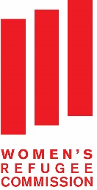

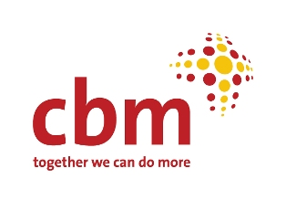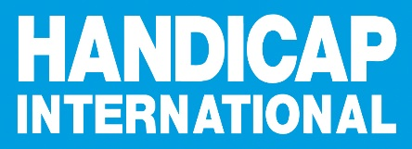

1. World Health Organization & the World Bank (2011) World Report on Disability.