المنظمة العربية للأشخاص ذوي الإعاقة

علم وخبر: 123/أ.د
مركز توفيق طبارة ـ الظريف ـ بيروت
تلفاكس:9611738296 /9611738297
هاتف جوال:9613654105
صندوق البريد: 5157 ـ113 حمرا،بيروت،لبنان
Arab Organization of Persons with Disabilities (AOPD)
Official Registration Number:123/A.D/Lebanon
Tabbara Center, Zarief Area, Beirut, Lebanon
TelFax: 9611738296/9611738297
Mobile:9613654105
Email:aodp@cyberia.net.lb
P.O.Box:113-5157-Hamra, Bierut, Lebanon

Call to Action:

Strengthening the Inclusion of Women and Girls with Disabilities

Affected by Humanitarian Crises in the Arab Region
We must work together to improve the protection, economic security, and representation of women and girls with disabilities who are displaced by crisis and conflict throughout the Arab Region. Improvements for women and girls with disabilities in situations of displacement can only be achieved through consultation with/and thoughtful inclusion of organizations and leaders who represent women and girls with disabilities. The Arab Organization of Persons with Disabilities(AOPD) calls on leaders from the UN Agencies, Local and National Governments, the International Media and Civil Society to prioritize actions and interventions which work to improve the situations of women and girls with disabilities who affected by humanitarian crises.

About the Arab Forum of Persons with Disabilities:

The Arab Organization for Persons with Disabilities (AOPD) is an independent non-profit organization founded in 1998 in Cairo, Egypt. AOPD aims to represent, empower, and promote the rights of Arab people with disabilities, as a regional organization composed of disabled peoples’ organizations (DPOs) operating in Arab countries. In 2006, AOPD launched the Arab Forum of Women with Disabilities a network of women representatives with different types of disabilities from 16 member countries, aimed at educating women and girls with disabilities on their rights and ensuring their equal participation in society.

On the 28th & 29th of April 2018, AOPD organized in Cairo(Egypt), under the patronage of His Excellency the Secretary General of the League of Arab States, Mr. Ahmed Aboul Gheit, and with the support of the Arab Gulf Development Program (AGFUND), the 3rd Regional Conference of the Arab Forum of Women with Disabilities(AFOWD), under the theme: "Cooperation for a safe and barrier-free world", in partnership with the Department of Women, Family and Childhood in the League of Arab States, Women’s Refugee Commission(WRC) and the Research and Training for Development Action Group.

The conference was attended by concerned stakeholders, women with disabilities from Arab countries, representatives of national bodies for women and ministries of social affairs in Arab countries, regional and international human rights organizations, national women's organizations, United Nations organizations, the OIC Secretariat and organizations of persons with disabilities, Arab NGOs working in the field, relevant regional and international experts, and civil society organizations concerned with women's issues from 16 Arab and foreign countries.

On the 30th of April,2018,a workshop on "Strengthening the Role of Women with Disabilities in Humanitarian Action" organized by the Arab Organization for Persons with Disabilities(AOPD) and the Women's Refugee Commission (WRC) , in which a group of girls and women with disabilities, mothers of children with disabilities and representatives of international and regional organizations participated.

During the workshop, 29 women with disabilities from 10 different countries shared their vision for inclusive humanitarian action. Over three days, our members discussed opportunities to improve the approach to humanitarian action in the region and principles to ensure inclusion of persons with disabilities in key initiatives. This advocacy brief summarizes the key recommendations developed by AOPD members with the aim to improve the lives of women and girls with disabilities who are affected by crisis and conflict in the Arab region.

Why we advocate for women and girls with disabilities affected by humanitarian crises:
Throughout the MENA region, women and girls with disabilities experience multiple forms of discrimination and are continuously excluded from all aspects of society. Those displaced by crisis and conflicts are especially affected. During the recent forum, we shared examples of human rights violations, including violence, abuse and exploitation, which affect displaced women and girls with disabilities in our countries. We also shared our views for progress. Women with disabilities, living as refugees in the region, expressed their desire to access livelihood and economic empowerment opportunities.
Overall, we find that women with disabilities are under-represented in all aspects of humanitarian action. We are not consulted or asked to share our experiences or expertise. AOPD is committed to take action and advocate for the rights of ALL women and girls with disabilities, including our sisters who are affected by crisis and conflict.

Recommended Actions:
Recognizing the complex humanitarian crises happening in our region, we want to draw immediate attention to the importance of ensuring women and girls with disabilities have their rights upheld and respected in all situations. We call on key stakeholders to initiate, lead and collaborate with the Arab Organization of Persons with Disabilities (AOPD) on the following actions:
- Include women with disabilities in economic empowerment and livelihood development programming:
- NGOs and host governments providing economic empowerment programs should consult directly with women with disabilities in the community to better understand their needs and desires in relation to training and livelihood programs. Networks such as AOPD can facilitate discussion with women with disabilities in the community.
- NGOs and organizations that already include women with disabilities in livelihood programs should document successes and lessons learned. In order to share best practices, organizations can collaborate with networks such as AOPD to jointly advocate other humanitarian actors to target and include women with disabilities in vital economic empowerment programs.

- Increase the representation of women with disabilities in leadership roles in humanitarian action:
- United Nations specialized agencies and other humanitarian actors should recruit women with disabilities to work in humanitarian response positions. Women with disabilities have diverse skills and capacities, including competences in program development, community mobilization, and advocacy. Networks such as AOPD can help agencies and actors identify strong, qualified women with disabilities to fill critical roles.
- Humanitarian coordinators should seek out and actively encourage organizations that represent women with disabilities to participate in humanitarian working groups and as representatives in coordinating mechanisms.
- Funding should be allocated to support local NGOs and DPOs to strengthen the capacity of women and girls with disabilities in crisis affected communities to represent and advocate for themselves.

- Expand access and provide targeted assistance to women and girls with disabilities in Gender-Based Violence (GBV) prevention and response programing:
- Organizations providing GBV services should connect with local organizations of women with disabilities to inform them about GBV risks, share information on available services and establish clear referral mechanisms.
- United Nations specialized agencies and their programmatic partners should collect and analyze disaggregated data on disability, sex and displacement. Agencies should consult directly with women and girls with disabilities to further understand how to make GBV services more inclusive. Networks such as AOPD can facilitate discussions with women and girls with disabilities in the community and identify key areas of collaboration.
- Organizations providing GBV services should immediately evaluate the accessibility of their services. Networks such as AOPD can provide consultation to help identify potential barriers prohibiting women and girls with disabilities from accessing services and can provide recommendations for improving services.

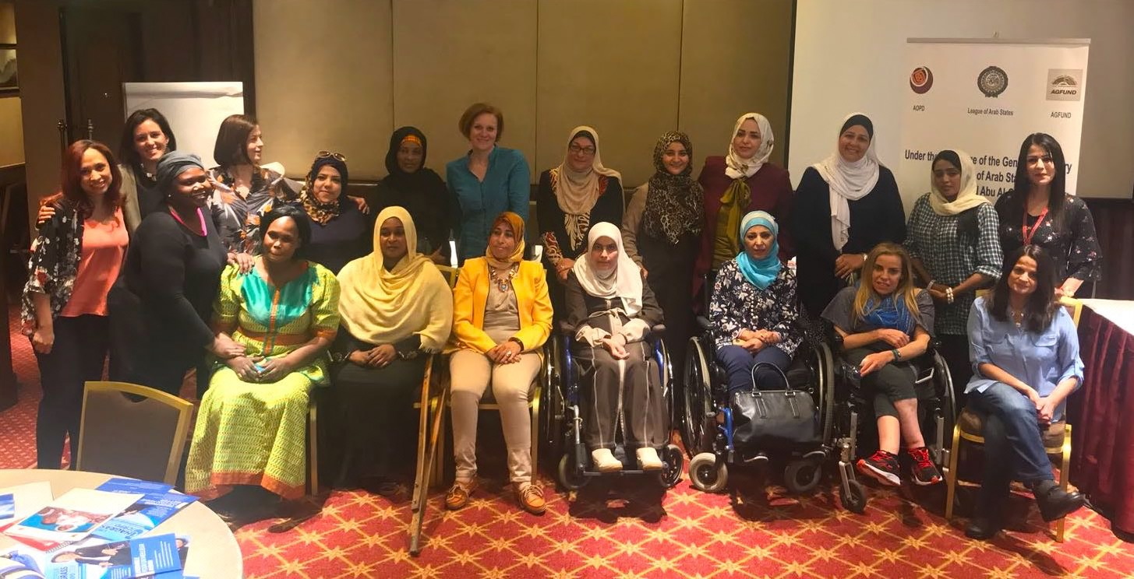

Photo: Participants from Arab Forum for Women with Disabilities Workshop on Strengthening the Role of Women with Disabilities in Humanitarian Action. Cairo, Egypt, April 30th 2018.

If you would like to explore possibilities for collaboration, please contact: Jahda Abou Khalil, Arab Organization of Persons with Disabilities: aodp@cyberia.net.lb. For more information on AOPD please visit: www.aodp-lb.net

