Women's Refugee Commission logo 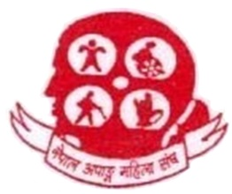 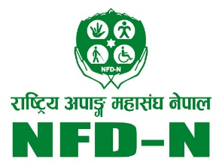 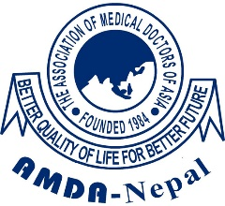

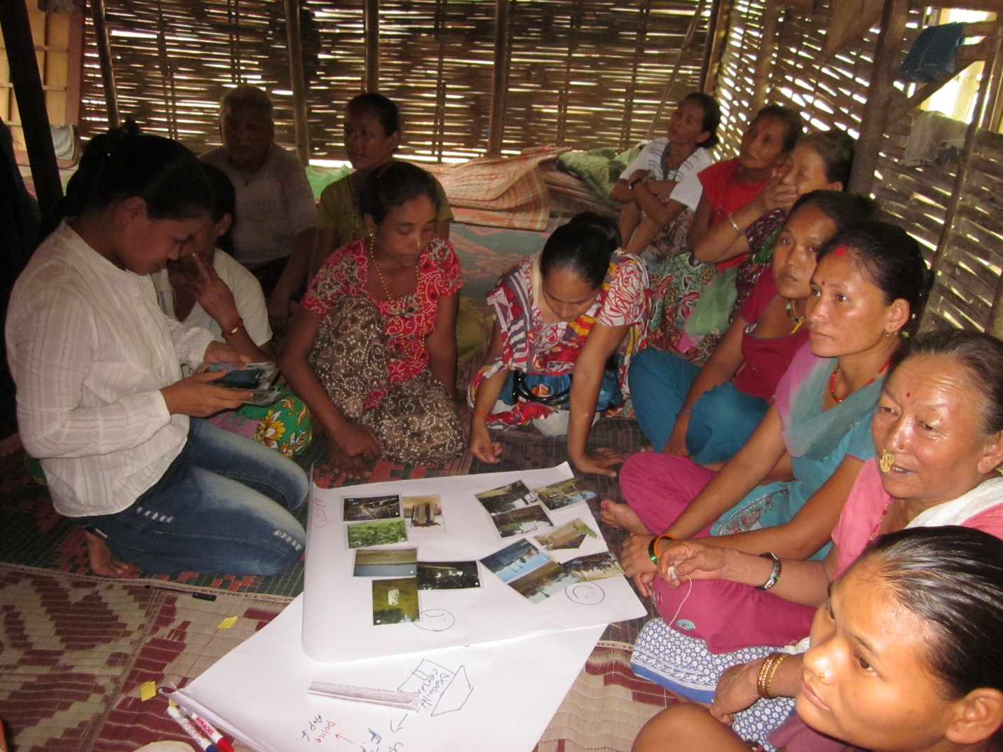

“It doesn’t matter if you are disabled. You are talented”

The intersection of sexual and reproductive health and disability for Bhutanese refugees in Damak, Nepal

December 2014

Research. Rethink. Resolve.

The **Women’s Refugee Commission** (WRC) works to improve the lives and protect the rights of women, children and youth displaced by crises. We research their needs, identify solutions and advocate for programs and policies to strengthen their resilience and drive change in humanitarian practice.

The **United Nations High Commissioner for Refugees** (UNHCR) leads and coordinates international action for the worldwide protection of refugees and the resolution of refugee problems. UNHCR’s primary purpose is to safeguard the rights and well-being of refugees.

The **Association of Medical Doctors of Asia** (AMDA) Nepal is UNHCR’s health implementing partner in the Bhutanese Refugee Camps in Damak.

The **Nepal Disabled Women Association** (NDWA) is a self-help organization led by women with disabilities that supports other women with disabilities through promoting health, education, representation and participation, economic em­powerment/livelihoods, capacity building, rehabilitation services and prevention and response to gender-based violence.

The **National Federation of the Disabled Nepal** (NFDN) is an umbrella organization of organizations of persons with disabilities established to protect and promote the rights of persons with disabilities in Nepal through enhancing their participation in decision-making pro­cesses.

**Acknowledgments**

This report was written by Mihoko Tanabe of the WRC. Erin Stone and Marisa Felsher contributed to the literature review. It was reviewed by Sandra Krause, Emma Pearce and Alison Greer of the WRC; Nirmal Rimal from AMDA; Atsuko Furukawa, Hansoal Park and Charlotte Feitscher from UNHCR; Rama Dhakal from NDWA; and Birendra Pokharel from NFDN. Diana Quick of the WRC edited and designed the report.

Mihoko Tanabe was overall responsible for study implementation and conducted the daily oversight. UNHCR and AMDA hosted the study, in partnership with NDWA and NFDN. Nirmal Rimal coordinated the project overall from AMDA, while Sudesh Regmi and Krishna Ranabhatt from AMDA provided administrative support. Atsuko Furukawa and Hansoal Park led the project from UNHCR Damak. Rama Dhakal and Birendra Pokharel provided Nepali-English interpretation and logistical coordination. Lutheran World Federation provided the data collector training space; Caritas Nepal the activities space in the camp; and the Damak Disability Helping Committee (DDHC) the debriefing room. The data were collected by Krishna Maya Adhikari, Khagendra Bhattarai, Manju Dhakal, Rama Dhakal, Srijana Kafle, Santoshi Tiwari (sign interpreter), Birendra Pokharel, Seeta Shilpakar, Parbata Shrest, Pritam Ghimire (sign interpreter) and Manu Maya Timsina. Caritas Nepal, UNHCR and the Camp Management Committee assisted with participant identification and recruitment.

A local advisory group provided input to the study and tools design. Members were: Dinesh Binod Pokhrel, Nirmal Rimal, Bidhya Basnet, Kiram Bam, AMDA Nepal; A.F.M. Risatul Islam, International Organization for Migration; Damber Kumari Subedi, Chhomo Rai, Disability Center Volunteer; Birendra Pokharel, Uttam Siwakoti, NDFN; Rama Dhakal, Bhima Khatiwada, NDWA; Prem Narayan Khanal, Refugee representative; Mwongeli B. Makau, Eirin Brohom, Ratna Maya Lama, Manoj Lakruwan Dassanayake, Salina Khatoonm; Rikke Olsen, UNHCR.

Technical assistance was also received for the global study from Muriel Mac-Seing of Handicap International, and Emma Pearce and Walei Sabry of the WRC. Kristen Schaus and Dhana Lama of the WRC provided logistical support.

The WRC and partners would like to thank refugees with disabilities and their caregivers who willingly offered their time, commitment and talents to implementing this project.

Photographs © UNHCR

Cover photo: Persons with disabilities participate in a workshop as part of the WRC’s consultative study design process.

© 2014 Women’s Refugee Commission

ISBN:1-58030-134-7

Women’s Refugee Commission | 122 East 42nd Street, New York, NY 10168-1289

+1.212.551.3115 | info@wrcommission.org | womensrefugeecommission.org

**Contents**

Acronyms and Abbreviations

Executive Summary

Key Learning

Key Recommendations

I. Introduction

II. Objectives

III. Nepal Context

IV. Methodology

V. Findings

VI. Key Considerations

VII. Conclusion

Notes

Annexes

Annex 1: List of cards depicting treatment of refugees with disabilities

Annex 2: List of photos from safety mapping exercise

Annex 3: Images of cards depicting treatment of refugees with disabilities:

Online at <http://wrc.ms/SRH_disab_Nepal_GBV_illustrations>

Annex 4: Photos from safety mapping exercise:

Online at <http://wrc.ms/SRH_disab_Nepal_photos>

Acronyms and Abbreviations

AMDA Association of Medical Doctors of Asia–Nepal

BRAD Bhutanese Refugee Association of the Disabled

CRPD Convention on the Rights of Persons with Disabilities

DDHC Damak Disability Helping Committee

DPO Organization of Persons with Disabilities

EC Emergency contraception

GBV Gender-based violence

IOM International Organization for Migration

LWF Lutheran World Federation

NDWA Nepal Disabled Women Association

NFDN National Federation of the Disabled Nepal

NGO Nongovernmental organization

SRH Sexual and reproductive health

STI Sexually transmitted infection

TPO Transcultural Psychosocial Organization

UNHCR United Nations High Commissioner for Refugees

WFP World Food Program

WHO World Health Organization

WRC Women’s Refugee Commission

Executive Summary

The needs of crisis-affected populations with disabilities are notably absent from global sexual and reproductive health (SRH) and gender guidelines and standards for humanitarian practice, despite the fact that Article 25 of the *Convention on Rights of Persons with Disabilities* (CRPD) states that persons with disabilities should have the same range, quality and standard of free or affordable health care, including in the area of SRH, as provided to other persons.

The Women’s Refugee Commission (WRC), the Association of Medical Doctors of Asia-Nepal (AMDA), the Nepal Disabled Women Association (NDWA) and the National Federation of the Disabled Nepal (NFDN), in coordination with the United Nations High Commissioner for Refugees (UNHCR), undertook a qualitative assessment of the specific risks, needs and barriers for Bhutanese refugees with disabilities to accessing SRH services in Beldangi refugee camp, Damak, Nepal. Their capacities and practical ways to overcome these challenges were also examined. The target population of refugees was those with long-term physical, intellectual, sensory and mental[1] impairments who experience barriers in society that hinder their full and effective participation on an equal basis with others. This group included women with disabilities aged 20-49 years; men with disabilities aged 20-59 years; and adolescent girls and boys with disabilities aged 15-19 years. Caregivers and family members of adolescent or adult refugees with disabilities were also consulted.

Participatory methods, based on a literature review and consultative processes, were applied. Participatory activities among refugees with disabilities included: mapping, sorting and timelines to explore knowledge of the reproductive system and fertility; community perceptions surrounding persons with disabilities and their SRH; barriers to accessing information and services; perceptions on how society treats persons with disabilities; and risk and protective factors. Activities among family/caregivers spurred discussion regarding new experiences and concerns that emerge as a result of a child maturing into a teenager or an adult, and experiences seeking health care for their child/family member with disabilities. Persons with disabilities were recruited as part of the study team from NDWA, NFDN and its local chapter—Damak Disability Helping Committee (DDHC)—to utilize their skills and capacities and facilitate empowerment processes.[2]

This study among refugees with a variety of disabilities in the Bhutanese refugee camps is one of three studies exploring the intersections between SRH and disability in humanitarian settings. In the Damak study, a total of 89 refugees with disabilities participated, of whom 50 were women and girls, and 39 were men and boys. Fifteen caregivers and family members of refugees with disabilities were also engaged.

**Key Learning**

* **Overarching concerns:** Refugees with disabilities and caregivers greatly appreciated agencies’ work to address the needs of persons with disabilities. They were particularly thankful for the disability identification card system that helps prioritize services for persons with disabilities, as well as Caritas’ provision of assistive devices, such as hearing aids, which has fostered participation in social activities. Several participants mentioned the positive work of the Bhutanese Refugee Association of the Disabled (BRAD). Caregivers of persons with intellectual and profound impairments worried about who would support their family member after they died or when they are no longer able to undertake this care-giving role. Adults with disabilities in particular was were concerned about the impact of resettlement on family cohesion and dynamics.
* **Awareness of SRH concepts and services:** Many adolescent and adult participants knew that AMDA, health workers and the Camp Management Committee provide SRH information to refugees with disabilities. Most participants had good knowledge about HIV and male condoms, through the work of AMDA and its awareness-raising campaigns. Knowledge of the reproductive anatomy, sexually transmitted infections other than HIV and family planning was comparatively less, especially among non-users of family planning services and persons with intellectual disabilities. To prevent pregnancy, group participants most often cited condoms, followed by injectable contraceptives (Depo-Provera), implants (Norplant) and pills. Many participants mentioned the accessibility of condoms in the camp, including through the public dispenser. No participant had heard of emergency contraception (EC) despite its being available in the camp.
* **Experiences around use of health and SRH services:** Participants reported positive changes in staff attitudes at the AMDA health center in the camp in the past 18 months, although more improvements were sought for staff at the referral hospital. Ongoing gaps include communication between persons with disabilities and providers—especially persons with hearing impairments—and disability accommodations relating to environmental accessibility (toilets and delivery bed). No participant mentioned a lack of service points to receive SRH information and services.
* **Experiences around romantic relationships:** Premarital relationships were generally scorned by women and girls with disabilities. Adolescent girls noted that they could be “cheated” in relationships due to their disability. Group participants suggested several outlets of information around relationships from the school counselor, Transcultural Psychosocial Organization (TPO) Nepal, Happy Nepal, mothers, AMDA, close friends, family members and neighbors. Marriage was a strong focus of discussion among women and girls, reflecting the importance of marriage in society, including for women and girls with disabilities. The need for love in a marital union was contested by female participants.
* **Experiences of women or girls with disabilities who become pregnant:** Adults and adolescents agreed that treatment of a pregnant woman or girl with disabilities by family and community members would depend on her marital status. Options for women and girls with disabilities who become pregnant include marriage and keeping the baby; elective abortion; forced abortion; and suicide. Women often associated pregnancy out of wedlock as an outcome of sexual violence, rather than the result of a romantic relationship. Pregnant adolescent girls and women with disabilities would deliver at the AMDA health center and the majority of participants felt she would be treated well by health staff during this process.
* **Autonomy of refugees with disabilities in their ability to exercise SRH rights:** Autonomy and decision-making around SRH were often linked to marriage.All groups across sex, age and impairment type demonstrated openness regarding contraceptive choice. Attitudes toward birth spacing to enable families to provide for their children appeared to be positive in the camp overall.
* **Perceptions around treatment of refugees with disabilities:** Participants agreed that violence against persons with disabilities was unacceptable, although not all seemingly negative scenarios were unanimously categorized as unacceptable. Female adults and adolescents with intellectual disabilities shared that forced sterilization could be acceptable, depending on the nature and severity of the impairment. Adolescent boys best framed their arguments using rights-based language, reflecting the impact of human rights education. Adolescents with intellectual disabilities were not always aware of the difference between appropriate and inappropriate touching, suggesting girls’ risks and exposure to molestation. A lack of self-esteem was evident among adults and adolescent girls with hearing impairments, who cited that they could not communicate well with friends or partners that did not sign and they feared discrimination in relationships and in school. Caregivers attested to the impact of sensitization in the camp, which they perceived to have generally reduced discrimination against persons with disabilities in the camp.
* **Safety concerns:** Participants unanimously identified the disability center, Lutheran World Federation (LWF), the UNHCR office and the vocational training center as “safe” locations. Predominantly “unsafe” locations included the forest/jungle, followed by the market and the communal kitchen. Caregivers shared protection concerns regarding their family members with disabilities who could be at risk of sexual violence, particularly those with intellectual impairments. Despite protection risks, no participant could identify health problems or consequences that could be prevented if they sought medical care in a timely manner after experiencing sexual assault. Participants who were home-based reported feeling safe with family members and caregivers; however, the home itself was seen as unsafe by some group participants where family members quarreled or became violent under the influence of alcohol. On the whole, men especially felt the camp was safer due to resettlement.

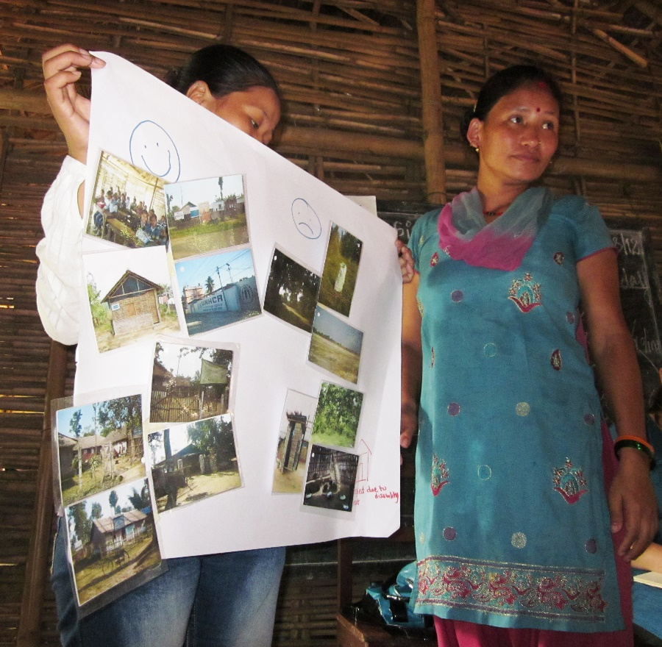

*Participants show which locations they consider safe and those that they believe are unsafe during the WRC’s consultative visit that preceded that study, in August 2012.*

* **Coping strategies, protective and facilitating factors:** Many participants had a strong social network, demonstrating the cohesiveness of the community. Refugees with disabilities also mentioned opportunities to share information, learn from each other and work with camp leadership as practical ways to serve as agents for change.
* **Recommendations from refugees with disabilities and caregivers:** Suggestions to improve their SRH experience include employing sign language interpreters in health facilities; expanding SRH awareness-raising activities; receiving priority access to services; providing spaces for peer learning as well as leadership, skills building and income-generation opportunities; and sharing more detailed information about the resettlement process.

**Recommendations**

**Donors and governments supporting agencies** servicing refugees should:

* Facilitate disability inclusion among agencies they support by providing funds for disability equality training for staff and funding for adaptive and flexible approaches.
* Support agencies to promote or facilitate the empowerment of refugees with disabilities and their families through providing funds for skills training, leadership, learning and income generation opportunities.
* Promote reflection and accountability on disability inclusion through monitoring and reporting processes.

**Agencies serving refugees**, **including through providing SRH services should:**

* Continue addressing disability as a cross-cutting issue—similar to gender considerations—with a dedicated budget for adaptive and flexible approaches to meeting the needs of the diverse clientele.
* Provide disability equality training to staff—including the referral hospital level—on communicating with refugees with disabilities in a respectful manner and understanding and appreciating the SRH rights of refugees with disabilities.
* Make sign language interpreters available at the AMDA health center and referral hospital, and providers can speak in louder voices for the hard of hearing. Develop the capacity of sign language teachers to address gaps due to resettlement.
* Prioritize outreach to refugees with disabilities who are isolated in their homes and target persons with intellectual and hearing impairments to increase their access to up-to-date and accurate SRH information and services.
* Provide focused messaging on the importance of seeking medical care in a timely manner after experiencing sexual assault, as well as information on protective strategies.
* Include adolescents with disabilities in existing adolescent SRH activities that are being implemented in the camp. For adolescents with intellectual disabilities, body mapping activities, pictures and models to convey critical SRH information—especially around acceptable touching—may be helpful aids to use in promoting their protection.
* Increase training opportunities for refugees with disabilities and caregivers—especially of persons with intellectual impairments—that address skills building, leadership and positive parenting in order to foster their independence, empowerment and longer-term SRH capacities.
* Continue to provide financial assistance, food support and income generation opportunities to refugees with profound impairments and their families, especially if caregivers are responsible for multiple persons with disabilities. Work with families to establish appropriate and safe care-giving arrangements so that primary caregivers are able to participate in these activities without protection concerns.
* Continue to support the work of the Bhutanese Refugee Association of the Disabled (BRAD), as well as provide spaces for refugees with disabilities and their families to learn from and help each other.
* Prioritize persons with disabilities and their families for resettlement according to their level of protection risk.
* Develop partnerships with the local organization of persons with disabilities—DDHC—to gain from its expertise in working with persons with disabilities, build bridges and facilitate stronger referral and support networks.
* Examine causes of disabilities and any preventative measures, taking into account the higher rates of hearing impairment among the Bhutanese refugees than among the Nepali population.

**Organizations of Persons with Disabilities (DPOs)** should:

* Offer technical expertise to agencies servicing refugees on how their providers and staff can better communicate with persons with different types of impairments.
* Advise agencies on where they can access sign language training and interpreters, where gaps in the camp exist.
* Advocate for refugee inclusion in national disability inclusion efforts, to enhance inclusivity of different populations in the region.
* Work with the Nepali sign language community to develop signs for SRH-related terms, such as menstruation, to facilitate dialogue around and understanding of SRH.

1. Introduction

In 2013, 51.2 million people were forcibly displaced by conflict and persecution,[3] and 22 million were displaced by natural disasters.[4] Persons with disabilities, defined under the *Convention on the Rights of Persons with Disabilities* (CRPD) as, “those who have long-term physical, mental, intellectual or sensory impairments which, in interaction with various barriers, may hinder their full and effective participation in society on an equal basis with others,”[5] are estimated by the World Health Organization (WHO) to comprise 15 percent of the global population,[6] a figure that is likely to be higher in situations of humanitarian crisis.

There is a growing body of literature that recognizes that persons with disabilities have historically been denied their sexual and reproductive health (SRH) rights.[7] They have less access to SRH information, which promotes healthy and safe relationships, protects them from HIV and other sexually transmitted infections (STIs), and enables autonomy in family planning decisions. The costs of exclusion can lead to poorer health outcomes and inefficient spending—for example, *treatment* for HIV in low- and middle-income countries amounts to US$8,900 per person over the life course, in contrast to an estimated US$11 to *prevent* one case of HIV. Lacking autonomy, many individuals with disabilities have been subjected to forced sterilizations, abortions and marriages because of ingrained stigmatization.[8] Recent reports to both the Human Rights Council and the United Nations (UN) General Assembly indeed highlight the multiple and intersecting forms of discrimination that are experienced by women with disabilities and increase their vulnerability to many different forms of violence, including gender-based violence (GBV).[9]

In 2008, the Women’s Refugee Commission (WRC) embarked on research that examined the protection concerns of persons with disabilities in humanitarian settings, releasing a report and a toolkit for practitioners.[10] In Nepal, Thailand and Ecuador, the field studies reported that refugee women with disabilities faced sexual violence, domestic abuse and physical assault.[11] More recent assessments conducted by the WRC with refugees and displaced persons in Bangladesh, Ethiopia, India (New Delhi), Lebanon, Nepal, Philippines (Mindanao), Thailand and Uganda found that violence was reported by both men and women with disabilities in all contexts. Women and girls with disabilities were most likely to report concerns about sexual violence, with concrete examples suggesting that those with intellectual and mental disabilities are most at risk. Isolation and lack of contact with community networks exposed both men and women with disabilities to violence inside the home. Further, adolescents and young persons with disabilities were excluded from peer activities that could facilitate the development of vital social networks and enhance their protection from various forms of violence, including GBV.[12] There is, however, a lack of information about the wider SRH needs and capacities of persons with disabilities in humanitarian contexts.

Article 25 (a) of the CRPD states that persons with disabilities should have the same range, quality and standard of free or affordable health care and programs as provided to other persons, including in the area of SRH and population-based public health programs.[13] However, the needs of persons with disabilities are notably absent from global SRH and gender guidance, and from humanitarian standards for practice. The standard guide for SRH in emergencies, the Inter-agency Working Group (IAWG) on Reproductive Health in Crises’ 2010 *Inter-agency Field Manual on Reproductive Health in Humanitarian Settings*, does not address issues of equitable SRH access for women, girls, boys and men with disabilities, or the specific SRH vulnerabilities and risks faced by this particular group.[14]

The WRC therefore undertook a project to explore the intersections between SRH and disability in three humanitarian settings, in Kenya, Nepal and Uganda. This report focuses on the experiences of adults and adolescents with disabilities in the Bhutanese refugee camps in Damak, Nepal. The study was undertaken in partnership with the Association of Medical Doctors of Asia-Nepal (AMDA Nepal), the Nepal Disabled Women Association (NDWA), the National Federation of the Disabled Nepal (NFDN), the Damak Disability Helping Committee (DDHC)—NFDN’s local chapter—and the United Nations High Commissioner for Refugees (UNHCR).

1. OBJECTIVES

The objective of the study was to acquire information on the SRH needs, vulnerabilities and capacities of refugees with disabilities. The study question explored: What are the specific risks, needs and barriers for persons with disabilities to access SRH services in humanitarian settings, and what are the capacities and practical ways that the challenges can be addressed?

Per the CRPD, “persons with disabilities” were defined as those who have “long-term physical, mental, intellectual or sensory impairments which, in interaction with various barriers, may hinder their full and effective participation in society on an equal basis with others.”[15]

“Barriers” were defined as environmental, attitudinal or structural barriers. Environmental barriers include physical and communications-related barriers; attitudinal barriers include individual, family, community, service provider and policy-maker attitudes; and structural barriers include policy- and resource-related barriers.

The term “disability” is used throughout this report to reflect the interaction between these different factors—impairments and barriers—as described in the preamble of the CRPD.[16] This definition is also aligned with the social model of disability that identifies that discrimination of persons with disabilities occurs, “not because of an impairment, but as a result of limitations imposed by the particular context in which people live.”[17] Hence, humanitarian actors can identify and remove these “disabling” barriers to access and inclusion in their programs.

“Sexual and reproductive health” was defined by the International Conference on Population and Development (ICPD) to include safe motherhood (maternal newborn health), family planning, STIs including HIV, and GBV.[18] More specifically, SRH addresses access to health care that helps women have safe pregnancies and deliveries; access for couples and individuals to safe, effective, affordable and acceptable methods of family planning; access for adults and adolescents to information and services on how to prevent and care for STIs, including HIV; and access to services for survivors of sexual violence.

Sub-study questions included:

* What are the specific SRH needs and risks faced by refugees with disabilities in humanitarian settings?
* What are the barriers (environmental, attitudinal and structural) and challenges for refugees with disabilities to accessing existing SRH services?
* What is the impact of stigma and caregiver/family/provider attitudes on access to SRH services for refugees with disabilities?
* What systems are in place to protect refugees with disabilities from SRH risk?
* What are the perspectives of refugees with disabilities of these SRH services?
* What communications strategies (including messaging, means, materials and others) are being employed to reach refugees with disabilities?
* What capacities and strategies have refugees with disabilities employed to meet their SRH needs and protect them from SRH risks?
* What additional facilitating factors can help refugees with disabilities meet their SRH needs and protect them from SRH risks?

1. nepal CONTEXT

**SRH of persons with disabilities in Nepal**

According to the 2011 National Population and Housing Census, 1.94% of Nepal’s population has some type of disability.[19] Persons with disabilities are among the most vulnerable in the country. Women with disabilities face additional disadvantages because of their gender; multiple levels of discrimination make them one of the most vulnerable populations.[20] In fact, Nepal was ranked 145th out of 187 countries in the UN gender inequality index.[21] Extreme poverty, poor education and stigma also create obstacles that prevent persons with disabilities from meeting their basic needs. During the civil war that ended in 2006, persons with disabilities experienced additional challenges to accessing health, rehabilitation and education services and earning a livelihood.

The rights of persons with disabilities have been recognized in the Interim Constitution of Nepal, which protects them from discrimination and guarantees access to employment and social security.[22] In May 2010, Nepal became a State Party to the CRPD and its operational protocol. The Convention guarantees the right to health care (including SRH), education, employment and social protection. The Ministry of Women, Children and Social Welfare subsequently drafted a disability law in line with the CRPD to replace the 1982 Act on the Protection and Welfare of Persons with Disabilities. It has also begun to help organizations of persons with disabilities (DPOs) to provide community-based rehabilitation activities and offer assistance to several rehabilitation service providers.[23] In 2012, Nepal’s Supreme Court ordered the government to offer more services for persons with disabilities, such as providing living allowances, building homes and posting a social welfare official in every district.[24]

Several DPOs and networks service persons with disabilities in Nepal. **NFDN** is an umbrella organization of DPOs established to protect and promote the rights of persons with disabilities in Nepal. It works for disability inclusion and mainstreaming in the national development process and seeks to enhance the participation of persons with disabilities in decision-making processes. From its inception, NFDN has been working in policy advocacy, awareness-raising and capacity building of persons with disabilities and DPOs.

**ADRAD-Nepal** is a human rights-based network of DPOs that was founded in 2008. The organization’s mass media-based advocacy campaigns have contributed to the Government’s ratification of CRPD. Its research and human rights monitoring have supported evidence-based advocacy and the development of the Government’s annual plan. Its work to mainstream persons with disabilities in development discourse has included support to internally displaced persons and refugees.

Established in 1994, DDHC promotes the status of persons with disabilities in Jhapa District. The activities of DDHC focus on the inclusion of persons with disabilities in all spheres of lives, including in the cultural, social, political and economic sectors.

**NDWA** is a self-help organization led by women with disabilities that works to empower women with disabilities in various sectors. NDWA and the Forum for Women, Law and Development (FWLD) are two of Nepal’s foremost women’s legal aid and women’s rights organizations that advocate on behalf of women with disabilities, particularly for SRH rights. In May 2009, the NDWA and FWLD formed a partnership in filing a public interest litigation on the health rights of women with disabilities. The Supreme Court of Nepal has already given the Directive Verdict to a hospital to implement recommendations.

NDWA supports women with disabilities by promoting health, education, representation and participation, economic empowerment/livelihoods, capacity building, rehabilitation services and prevention and response to GBV. NDWA’s 2007 research found that 54 percent of surveyed women with disabilities were experiencing general health issues due to their disability. Forty-five percent of respondents reported SRH issues such as urinary tract infections, recent abortion or abnormal discharge, and 55 percent had experienced sexual violence. Among survivors, 25 percent were sexually violated by their own husbands. Forty percent of disabled women were not aware of contraceptives and 15 percent had not received any information about menstruation. The study further found health care and facilities provided by the Govern­ment to often be inadequate, particularly for persons with intellectual and developmental impairments. As a result, the SRH needs of women with disabilities are frequently neglected.[25]

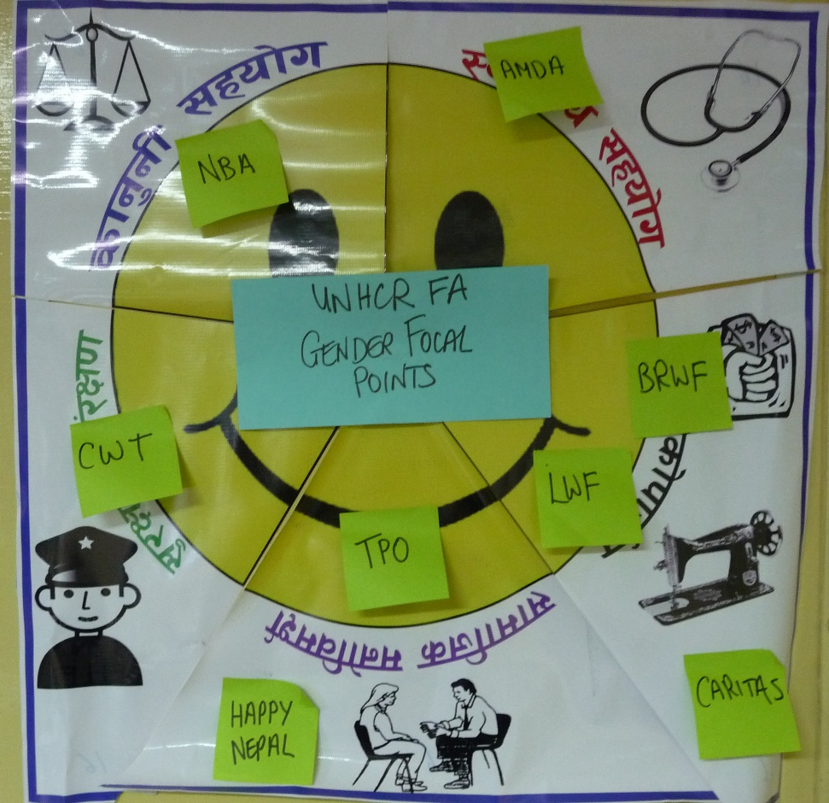

Human Rights Watch has found that while Nepal has made important progress toward achieving universal primary education, children with disabilities represent a significant portion of the approximately 330,000 primary school aged children who remain out of school. Children with disabilities often do not receive any education, including sex education. Several key informants in the study indicated that some parents seek involuntary sterilization for their daughters with disabilities to prevent unwanted pregnancy.[26] Further, according to the 2011 New Era for National Planning Commission report, 68.2 percent of persons with disabilities had no education compared to 4.8 percent of the general population.[27]

**Displacement in Nepal**

The majority of refugees are Lhotshampas, one of Bhutan’s three main ethnic groups that was forced to leave Bhutan in the early 1990s.[28] The Bhutanese refugees live in refugee camps based in Jhapa and Morang districts in southeastern Nepal. As of August 2014, there were 5,219 Bhutanese refugees in Sanischare Refugee Camp and 20,214 in Beldangi Camp and its extensions.[29] Third country resettlement was rapidly taking place at the time of study implementation in August 2014.

**Situation for refugees with disabilities in Nepal**

According to Caritas Nepal, which operates a disability program in the camps, as of March 2014, there were 854 persons with disabilities living in the two camps, representing approximately 3.4 percent of the total population. Hearing impairments, including deafness, are the most common type of impairment (52.5%). This is followed by physical impairments (23.4%), mental impairments (15.6%), intellectual impairments (12.7%) and visual impairments (7.5%). Those with multiple impairments, speech impairments and autism comprised roughly 3% of the registered persons with disabilities.[30] In contrast, Nepal’s 2011 Census found that only 15.4% of the Nepali population of persons with disabilities are Deaf or hard of hearing.[31]

**NDWA** has aimed to increase the capacity of refugees with disabilities through sensitizing women about their rights as refugees and as persons with disabilities. They also raise awareness on refugee law, national law and legislation regarding refugees with disabilities in the camps.[32] Since 2013, NDWA has been working with UNHCR and the WRC to promote the inclusion of disability services in all services provided in the camp.

**Caritas Nepal** operates disability centers for children and adults, helping those with physical impairments access specialized rehabilitation services; offering sign language classes to refugees, caregivers and service providers; and providing education to students with hearing, visual and physical impairments. Caritas offers safe spaces for refugees with disabilities to congregate.[33] **TPO Nepal** also operates programs in the camp, particularly psychosocial services for persons with mental impairments.

**AMDA Nepal** is UNHCR’s health implementing partner in Sanischare and Beldangi Camps. AMDA provides comprehensive SRH services to refugees, including to persons with disabilities, around maternal newborn health, family planning, STIs/HIV/AIDS and GBV. AMDA’s robust program offers skilled delivery care, family planning, HIV voluntary counseling and testing (VCT) and clinical care for survivors of sexual assault. Any referrals are made to the AMDA Hospital and/or the government secondary and tertiary hospitals. Tertiary care is offered at the B.P. Koirala Institute of Health Sciences. Medical-legal linkages for sexual assault are made through the Nepali system. AMDA also provides medical escort services for sexual assault survivors. AMDA has overcome many of the challenges faced by other providers of SRH in humanitarian contexts, including enabling client access to emergency contraception (EC) beyond post-rape care; achieving 100 percent skilled attendance at birth; supplying female condoms; providing adequate follow-up to family planning clients; and embarking on the provision of youth-friendly services to address adolescent SRH needs. Most people seek health care for sexual assault do so within 72 hours of the incident.[34]

At the time of the study, AMDA was preparing to launch a community-based SRH Project for implementation by select members of the camp’s Youth Friendly Centre (YFC). The project aims to provide consultation hours on SRH, equip YFC libraries with SRH related books, implement monthly awareness raising-activities and include different stakeholders in the process, including the Disability Centers.

**SRH and refugees with disabilities in Nepal**

In a review of the literature in 2012, no research was found that explored SRH issues among refugees with disabilities in the Bhutanese refugee camps. According to UNHCR’s ProGres database and GBV Trend Analyses, from 2009-2014, 23.4 percent of all rape survivors across the camps were persons with intellectual and/or physical impairments, and 10.5 percent of the survivors had intellectual impairments. In 58 percent of the reported rape cases, the alleged perpetrator was an acquaintance of the survivor, and 57 percent of incidents occurred either in or close to the survivor’s hut.[35]

1. METHODOLOGY

The WRC convened meetings with DPOs and other stakeholders in Damak and Kathmandu to collectively develop the participatory research methodology in advance of the field assessments and select a local co-investigator (AMDA) to assist with the ethical clearance process. An advisory group comprising DPOs, NGOs and representatives of refugees with disabilities was established as a result. The Nepal advisory group is one arm of the global advisory group for the wider project that also includes representatives from Kenya and Uganda. Collectively, the advisory groups informed the development of the study design and instruments. The study was approved for implementation by the Nepal Health Research Council (NHRC). The team lead from the WRC received camp approval from the Nepal Government’s Ministry of Home to work in the Bhutanese refugee camps in Jhapa and Morang Districts. In coordination with UNHCR, AMDA hosted the study in Damak, with participation from NDWA, NFDN and its local affiliate, DDHC.

IV.I. Study participants

The target populations selected for this study are:

* Refugees with **physical**, **intellectual**, **sensory and mental impairments** among the following age groups:
* Women of reproductive age with disabilities (20-49 years)
* Men with disabilities (20-59 years)
* Adolescent girls with disabilities (15-19 years)
* Adolescent boys with disabilities (15-19 years)
* Caregivers/family members who care for adolescent or adult refugees with disabilities

Refugees with disabilities for inclusion in this study represented those who self-identified with the CRPD definition of persons with disabilities. Additional guidance was given to those involved in the study to ensure that members were aware of the variety of impairments encompassed in the CRPD definition and invited such persons to participate in the study**:**[36]

* **Persons with long-term difficulty moving, walking or climbing steps (physical impairments).**
* **Persons with long-term difficulty seeing, even if wearing glasses (vision impairments).**
* **Persons with long-term difficulty hearing, even if using a hearing aid (hearing impairments).**
* **Persons with a mental health condition that alters their thinking, mood or behavior, and is associated with distress or interference with personal functions (mental impairments).**
* **Persons** who have **difficulty understanding, learning and remembering new things, and in applying learning to new situations (intellectual impairments).**
* **Persons who have multiple impairments and/or severe functional limitations, often unable to leave their homes and may need assistance with all personal care.**

The primary focus of the adults with disabilities groups was up to 49 years for women and 59 years for men, similar to the cut-offs of the global Demographic and Health Surveys.[37] The age cut-off between adult and adolescent groups was 19, taking into account WHO’s definition of adolescents as 10-19 years of age.[38] Among caregivers and family members, priority was given to those who were caring for adolescents or adults with disabilities.

IV.II. Participatory activities

The study used qualitative, participatory methods to enable a cross-sectional examination of the specific risks, needs and barriers for refugees with disabilities to accessing SRH services, and the capacities and practical ways that the challenges could be addressed. Based on a literature review and the consultative process with the study’s advisory groups, the selected participatory activities included body mapping,[39] timelines[40]and sorting[41]to explore knowledge of the reproductive system and fertility; community perceptions surrounding refugees with disabilities and their SRH; barriers to accessing information and services; perceptions around different types of treatment; and risk and protective factors.[42] To gauge how refugees with disabilities perceived various treatment towards persons with disabilities, 25 cards were developed with pictorial scenarios and accompanying text, for participants to sort into categories of “acceptable,” “unacceptable” or possibly both. In order to determine safe and unsafe spaces, participants sorted 20 photographs of the camp and its vicinity to show whether the locations were seen as safe, unsafe or both. Activities were adapted with visual aids, simple language and other modifications to enable maximum participation by refugees with different impairments.

Activities among family members/caregivers were intended to spur discussion regarding new experiences and concerns that emerged as a result of the child/family member maturing into a teenager or an adult, and experiences seeking health care for their child/family member with disabilities.

IV.III. Sampling and segmentation

The overall study design employed a maximum variation approach seeking to include different populations of refugees with disabilities in Beldangi Refugee Camp. Participants were stratified into four groups based largely on communication methods, in addition to segmentation by age, sex and language (two languages, including Nepali sign). These were:

* Group activity

1. Refugees with physical, vision and mild mental (psychosocial) impairments
2. Refugees with hearing impairments
3. Refugees with mild intellectual impairments

* Individual interview

1. Refugees with other needs and impairments that required more individualized communication approaches (those unable to leave their home; those with multiple impairments; new mothers; etc.)

* Caregiver/family member focus group discussion

The groups were fluid and were divided by participants’ ability to **functionally communicate** with other participants and the facilitator. The aim was to secure wide representation and participation. Those in the “refugees with physical, vision and mental impairment” group also included other refugees with disabilities who could use similar means of communication.

While Caritas’ and TPO Nepal’s records of refugees with disabilities, as well as Caritas staff knowledge of persons with disabilities were used to identify participants with different impairments, no official assessment was undertaken to verify or “diagnose” impairment types. The priority was to ensure participants could communicate and participate with the accommodations made for the particular group. In groups where varying impairments were represented, the facilitators were trained to probe within each group about any differences in experiences across the represented impairments.

Smaller group activities were convened among refugees with mild intellectual impairments to ensure the sessions were facilitated well enough for everyone to participate. Individual interactions were used for persons with multiple disabilities, new mothers and other persons for whom in-depth activities at a person’s home were more appropriate than a group environment.

Different study instruments were used for group and individual activities, which were field tested in Sanischare Camp prior to the assessment to ensure acceptability and validity. Among caregivers/family members, the same interview guide that was used for focus group discussions was used as an interview guide for those who were unable to leave their homes.

Participants were identified from existing lists of refugees with disabilities. Standard approaches to qualitative research for focus group size (6-12) and number were applied where feasible.[43] In total, 89 refugees with disabilities participated in the study, of whom 50 were women and girls and 39 were men and boys. Fifteen caregivers and family members of refugees with disabilities were also consulted. The activities were conducted in Nepali and Nepali sign.

**Table 1: Number of participants consulted in Beldangi Refugee Camp**

|  |  |  |  |  |  |
| --- | --- | --- | --- | --- | --- |
|  | Total | 1. Refugees with physical, vision and mild mental (psychosocial) impairments | 2. Refugees with hearing impairments | 3. Refugees with mild intellectual impairments | 4. Other refugees (who are unable to leave home, have multiple impairments, new mothers, etc.)**** |
| Women of reproductive age (20-49 years) | 40 | 10* | 24** | 2 | 4 |
| Men (20-59 years) | 29 | 15 | 11 | 3 | 0 |
| Adolescent girls (15-19 years) | 10 | 1 | 2*** | 6 | 1 |
| Adolescent boys (15-19 years) | 10 | 4 | 1 | 5 | 0 |
| Caregivers/family members | 15 | 13 | | | 2 |

* Several groups under category 1 included those hard of hearing, as they could follow the means of communication and preferred this style over Nepali sign.

** Although listed under this group, some women with hearing impairments also had physical disabilities.

*** Due to participant numbers, there was only one participant in one of the group activities. The group guide was used however, as the participant was best positioned to answer those questions.

**** One interview with a couple with multiple impairments was removed from the final count, as they exceeded the age bracket.

IV.IV. Participant recruitment

Refugees with disabilities were recruited through stratified sampling from Caritas’s registration lists provided to the WRC through UNHCR, as well as through the Disability Center staff network. The WRC reviewed the registration lists containing 854 persons with disabilities and sorted the lists by sex, age, type of listed impairment and camp location. Those that were above and below the age cut-off were removed from the lists. Six hundred and thirty three persons remained after this process, of whom 447 persons were listed as residing in Baldangi Camp. The WRC staff person then identified the “nth” person through stratified sampling to secure the numbers needed per group. Persons with mental impairments were recruited from registration lists managed by TPO Nepal.

Via UNHCR’s field associates, the Camp Management Committee (CMC) that is responsible for certain sections of the camp contacted selected participants through home visits or cell phone calls. Where selected participants were unavailable to participate in group activities due to resettlement; degree of their impairment; other commitments; or lack of interest to participate, Caritas’ Disability Center staff actively reached out to other persons with disabilities and/or their families via cell phone to gauge their interest in participating. For selected participants who were isolated to their homes, the activity was converted into an interview, and data collectors made home visits to conduct the activity. In cases where the selected participant was found to have a heavy intellectual or mental impairment that affected their ability to communicate with the recruitment staff, the caregiver was invited to participate in a caregivers’ focus group session or an individual interview.

As part of participant recruitment, the CMC and Caritas staff explained the broad purpose of the activities and expectations around the activity. Focus was placed on the activities as an opportunity to inform service improvement in the camp. An informational flier noting objectives, expectations and use of findings was made available to potential participants in Nepali and Nepali Braille.

IV.V. Study team composition and training

The WRC recruited six data collectors (four women and two men) and two Nepali sign interpreters from NDWA, NFDN and its affiliate partner—DDHC—from Damak and Kathmandu. The core team included two blind persons (female and male), one Deaf woman and three persons with physical impairments (two female and one male). The full team, with support staff/assistants, comprised 12 persons.

The data collectors, assistants and sign interpreters participated in a four-day training on human subjects research; SRH topics; appropriate communications skills; facilitation and recording skills; consent/assent processes; ethical data handling; and referral pathways to existing health, protection and psychosocial services. The training also consisted of time to adapt facilitation techniques to ensure that persons with visual and hearing impairments could lead and facilitate group activities.

The trained interviewers piloted the study instruments and tools (images, photos, etc.) in Sanischare Camp before they engaged in actual data collection in Beldangi Camp. They further received frequent support and review of skills throughout data collection, particularly during daily debriefing sessions that took place every afternoon. Team members ultimately comprised facilitators, note-takers, “supporters” and sign interpreters. The supporters assisted the facilitator and note-takers as necessary.

IV.VI. Informed consent

Informed verbal consent was sought from all participants in Nepali or Nepali sign and tailored to accommodate different impairments. The consent process included information on how participants were selected, the nature of the activities and the types of questions they would be asked if they consented. Potential participants were assured that individual names would not be collected or used in any findings, and that their ability to access services was not contingent upon participation. Consent processes were conducted in advance or immediately before the activity. Only those participants who consented were permitted to participate in the activity.

To ensure adequate understanding of their involvement in the activities, the consent/assent process for participants—especially for those with mild intellectual impairments—was interactive. As applied in other SRH-related studies,[44] once the objectives and the process had been explained, the facilitator asked the following questions:

1. What will we be talking about in the activity?
2. How long will the activity be?
3. Can you think of a reason why you might not want to participate?
4. If you do not want to answer any of the questions, what can you do?
5. When would I have to tell someone else what you have told me?
6. Are you still happy to take part in this study?

Potential participants were required to answer questions 1, 4 and 5 correctly, and a “yes” needed to be obtained for question 6. For those that answered the critical questions incorrectly but still expressed interest in participating, the protocol sought caregiver/family member permission. In many cases, the caregiver accompanied participants with heavier impairments to the activity venue, which made seeking caregiver/family member permission relatively smooth, should it have been necessary.

Per Nepali law, minors (15-17 years) were asked to provide verbal assent, and a parent/guardian was asked to provide verbal permission, in advance of activities. Parental permission was sought by the CMC or Disability Center staff. For adolescents that provided initial verbal assent and for whom parental permission had been obtained, the facilitator sought onsite verbal assent from the adolescents using the above six questions when the time came to conduct the activity. Pregnant girls, those who have children or those who were married or living on their own were determined eligible to provide their own consent.

Caregivers/family members who participated in activities were also asked to provide verbal consent immediately prior to the start of the activity.

IV. VII. Other ethical considerations

Individuals were informed of existing health or psychosocial services if they revealed recent experiences of violence or requested additional information and services. The referral system built on UNHCR and AMDA’s own services, as well as the existing network of partner organizations. UNHCR was also informed of cases that required individual follow-up, especially where requested by the participant.

Personal identifiers were collected only to make initial contact with potential participants for recruitment purposes. During data collection, no personal identifiers were retained from any study participant in either direct or coded form. Mappings, timelines and other posters developed during participatory exercises were photographed for translation and data analysis. All outcomes from sorting activities were recreated by data collectors during the daily debriefing sessions for photographing purposes—aided by the note-takers’ notes—to ensure that no photographs were taken in the presence of participants. NFDN and DDHC collected the data collectors’ handwritten notes at the end of data collection activities and stored the notes in their respective offices. Typed transcripts were available only to WRC staff involved in the study for data analysis.

IV.IX. Data analysis

Preliminary data analysis began at the end of each day when the study supervisor from the WRC, facilitators, note-takers, supporters and, where appropriate, the sign interpreter, convened to debrief on the day’s activities. Female team members reviewed responses to each activity and question and directly translated their notes for the study supervisor to type notes in English. For men’s activities, the blind facilitator transcribed notes in English on his laptop, aided by the note-taker who had taken handwritten notes in Nepali.

On the last day of activities, the WRC facilitated a discussion among the team members on their views and analysis. The team presented preliminary findings to UNHCR and AMDA staff in Damak for immediate action as a more comprehensive analysis was undertaken.

Upon completion of data collection, the WRC analyzed the transcribed data on NVivo 10, a qualitative data analysis software, and Excel. Photographs of the violence and treatment sorting activities were included to support the verbal transcripts. Findings were analyzed within and between activities, with comparisons made across sex, age and impairment group of participants, where feasible.

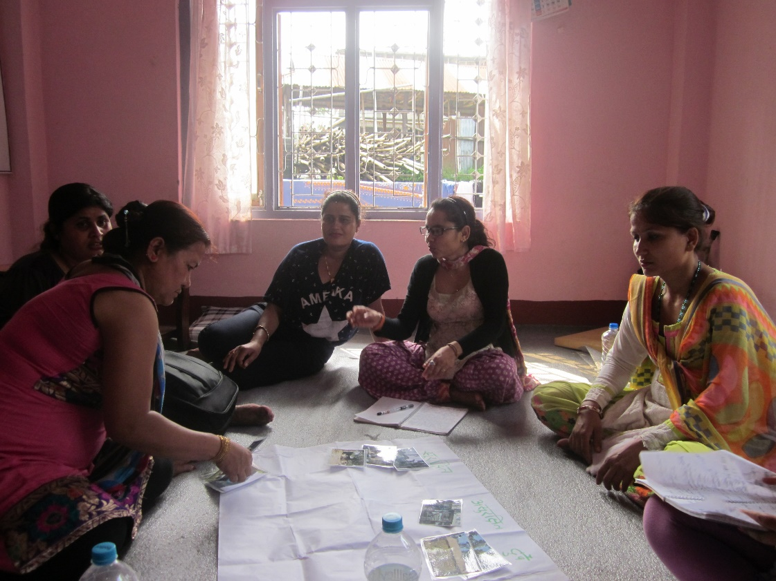

IV.X. Limitations

Not all impairments and ages were adequately represented in the study to draw disaggregated findings. This was particularly the case for adolescents and those with mental impairments. Due to advanced resettlement processes, many adolescents had been resettled; hence, the number of girls and boys that ultimately participated was much less than originally planned and data saturation was affected as a result. This is especially the case for adolescent girls with physical, visual, mild mental and hearing impairments, as well as adolescent boys with hearing impairments. As for persons with mental impairments, resettlement had also impacted remaining numbers and those that met the study eligibility criteria in terms of age and degree of disability.

Due to the number of adult participants with hearing impairments, the data may be skewed towards this group overall. However, given that persons with hearing impairments comprise the largest impairment type per registration data, any focused emphasis on this group was felt to be justified.

Additionally, given that groups were segmented based on participants’ functional ability to communicate, some groups had spill-overs from other categories; for example, several groups of women with physical impairments also included those that were hard of hearing or those with both impairments, as they preferred groups that solely used voice over dedicated groups that used sign language. Several men’s groups also had spill-overs of persons with other (primarily physical) impairments. Analysis thus focused on general and common findings across refugees with disabilities rather than attempting to solicit saturation by impairment group or even age. In some instances, findings were isolated by impairment type or age, if one individual in particular was skewing group dynamics. Contributions from one adolescent girl in a group of girls with intellectual impairments was omitted, where responses were not consistent with the questions asked.

Groups using sign language experienced additional challenges; refugees with hearing impairments used different forms of sign language, as not all persons had enrolled in school and many relied on their own forms of sign. Moreover, some SRH terms did not exist as words in Nepali sign—such as menstruation—some concepts were thus challenging to interpret and explain. To adequately engage all participants, for the women’s signing group in particular, the facilitator spoke loudly and signed, while three other data collectors used various forms of sign to reach as many participants as possible. Given that conversations could still be maintained, this method appeared effective; however, some participants may not have been able to follow every conversation thread.

The study employed facilitated translation techniques where transcription was conducted immediately after the activity on the same afternoon with the facilitator, note-taker, supporters and the transcriber.[45] Multiple data collectors taking notes in most activities minimized recall bias and omitted information; however, the possibility of translation error exists, given that English was a second language for all team members.

1. FINDINGS

V.I. Overarching concerns

Overall, persons with disabilities and caregivers deeply appreciated the work that agencies have done to address the needs of persons with disabilities. They were particularly thankful about the disability identification card system that helps prioritize services for persons with disabilities, as well as Caritas’ provision of assistive devices such as hearing aids, which has fostered participation in social activities. Several participants also mentioned the positive work of the newly formed Bhutanese Refugee Association of the Disabled (BRAD) in the camp. Adult men with physical impairments, for example, said, “There is BRAD that just opened and is now engaged for providing services better to persons with disabilities.”[46] One caregiver of a person with an intellectual impairment said: “Now, there are many more facilities given to disabled persons, like computer training, tailoring and hotel management. These are provided by Caritas Nepal and TPO Nepal. They look after us properly.”[47]

A handful of persons with disabilities even stated that they did not feel as though they were disabled, since they did not face challenges as a result of their impairment, or they believed others were experiencing harder circumstances.

Despite efforts to date, some persons with disabilities and their families requested additional support from agencies, including food assistance, skills training and visits by health workers. Elderly caregivers of persons with heavier intellectual impairments commonly voiced fears such as, “If I pass away, what will the situation be for my child?...They will cry and die from hunger. They will be in big trouble.”[48] Other caregivers, especially those who were more isolated, spoke of challenges in caring for their family. For example, one caregiver of three adult children with intellectual and other profound impairments explained, “I am the only one that is taking care of the family…Sometimes, I become sick, and in this case, it is very hard. When I am sleeping and something happens, if I try to call or go to the neighbors, nobody can hear [since the neighbors are Deaf].”[49] This case reflected protection concerns in addition to hardships incurred as a result of limited social interactions and support.

The impact of the resettlement process was frequently woven into participant dialogue. For instance, one adult man in a group of persons with a physical impairment remarked, “The services now are much better than in the past because there are very few refugees left.”[50] For others, resettlement impacted family composition and dynamics. An adult woman in a group of women with physical and hearing impairments said: “If we have to stay in Nepal, we are citizenless. If we go to another country, we can be a citizen. My parents were in the U.S. for five years. I have not met them and I feel alone. There is no one to talk to, except my husband and his family. I am not so comfortable with them; I miss my maternal family.”[51]

V.II. Awareness of SRH concepts and services

Both adolescent and adult participants frequently said that AMDA, health workers and the CMC provided information and services for SRH. The radio was mentioned as a source of information, especially on HIV. Other outlets of information include Lutheran World Federation (LWF), International Organization for Migration (IOM), UNHCR and Caritas, as well as friends, neighbors, families, community members and other media outlets.

In a body mapping exercise, while some participants knew where the female and male reproductive organs were located and what their functions were, most were not very clear about their anatomy. Participants with mild intellectual impairments had more difficulty identifying and locating body parts, and were generally less aware about how their bodies functioned. Adolescent girls and boys generally knew less than adults. Women were less aware about male organs than about female organs.

Most group participants had good knowledge about male condoms and HIV (what it is and modes of transmission) through the work of AMDA and its awareness raising campaigns, which include "International Condom Day.[52] Even among participants who were less aware of nuances—such as groups of persons with intellectual or hearing impairments, or those who were home-based—a number of participants, including an adolescent girl with an intellectual impairment, could link the use of condoms to HIV prevention.[53] Only a small fraction of participants, including a Deaf woman, had not heard of or seen a condom.[54]

Misconceptions around HIV, such that it could be spread by hugging or talking, were observed among adolescent girls.[55] [56] Despite generally good exposure to HIV information overall, participants were much less aware about other STIs. One or two adult participants in each group could name examples, primarily syphilis and gonorrhea; however, when probed about signs and symptoms, the majority of participants—across sex, age and impairment group—could not describe them correctly.

To prevent unplanned pregnancy, group participants most often cited condoms, followed by injectable contraceptives (Depo-Provera), implants (Norplant) and pills. Many participants mentioned the accessibility of condoms in the camp, including through the public dispenser. Women who were using family planning methods were generally more familiar than other participants groups with options to space births. On the whole, participants appeared to know less about the intrauterine device. Only one woman in a group of persons with physical, visual, mild mental and hearing impairments had heard of the female condom; only men (including signing men) reported both having heard of and seen a female condom before. Among adults who had heard of permanent methods, vasectomy was mentioned more often than female sterilization. No participant had heard of EC, despite its availability in the camp.

V.III. Experiences around use of health and SRH services

The majority of persons with disabilities reported receiving quality services and treatment from health providers at the AMDA camp clinic. Many said that staff attitudes had improved tremendously over the past 18 months. For instance, an adolescent boy in a group of males with physical and visual impairments felt: “The health staff are friendly to persons with disabilities and this has been improved these days.”[57] A mother of three heavily disabled grown children further explained, “If I carry the child to the health center, nobody cares about her. I have to wait outside the queue. My child roams around and can’t stay in one place. Now, things are changing. When I go to the health center, they let me come first because they know I have many disabled children.”[58]

However, those who use sign language or are hard of hearing often mentioned the limited options to communicate with health providers, since sign language interpretation is not available at the AMDA health facilities. One man in a group of signing participants noted, “The health staff are helpful to persons with disabilities; however the help of family member is essential to communicate with them….The services are satisfactory. We can't enjoy in a proper way only because of barriers in communication.”[59] Family members in similar situations echoed, “My wife is hard of hearing. In the health center, there is not a sign language interpreter. Sometimes, I go to work, so she cannot receive the service. This is very challenging and is a problem.”[60]

A handful of persons with disabilities noted that the toilets and the delivery bed were not very accessible.[61] No participant said that there was a lack of service points to receive SRH information and services inside the camp.

Despite shared appreciation for the quality of health services and provider attitudes inside the camp, many participants felt they were treated with less respect by health staff at the AMDA referral hospital in Damak. A caregiver of a person with an intellectual impairment commented, “In this camp health center, the staff provide good treatment, but in AMDA Hospital in Damak, the staff behavior is not good.”[62]

V.IV. Experiences around romantic relationships

In an exercise to map typical exposure to and experiences around romantic relationships among adolescents with disabilities, feedback was mixed across groups, although premarital relationships were generally scorned. On the whole, groups of men and boys appeared to be more forgiving about premarital relationships, while adolescent girls and women were less forgiving of such relationships.

A school-going adolescent girl with a visual impairment, for example, said: “In student life, we should not do this activity. When we grow up, our parents will find the best husband….My mother used to say that to study better, we should not go with bad men. We should not fall in love.”[63] Participants in fact noted few romantic relationships among unmarried persons. A signing adolescent boy however, stated, “When they grow to adolescence, the Deaf boys and Deaf girls have romantic relationship.”[64]

If a relationship is discovered, participants said, “The family and neighbors will say you are spoiled, you are not good.”[65] Very few participants felt that parents and neighbors would be supportive of the relationship.[66]

Mistrust was seen around relationships, especially among adolescent girls. For example, an adolescent girl with an intellectual impairment said, “First, boys will show their love and attract towards them. After that, they will cheat.”[67] Disability was linked to mistrust around relationships that were voiced by several girls with disabilities.

For adolescents in relationships, group participants suggested several outlets of health information. Adolescent girls with physical and visual impairments listed the school counselor, TPO Nepal and Happy Nepal.[68] Mothers were also mentioned by many female groups, including for information around menstruation. A woman in a group of persons with physical, visual, mild mental and hearing impairments said: “My mother taught me to sit neat and clean and to wash and hang the pad in the sun. There may be a chance of getting tetanus if we don’t do this,”[69] shared a woman in a group of persons with physical, visual, mild mental and hearing impairments. AMDA, close friends, family members and neighbors were further mentioned as sources of information, including from by adolescents and signing women.

Marriage was a strong focus of discussion, especially for women and adolescent girls with disabilities whose views underscored the importance of marriage in society, and of marriage serving as an important coming-of-age marker for any Bhutanese woman or girl. One woman with physical and hearing impairments said, “It doesn’t matter if you are disabled. You are talented, so there is no problem in marrying you.”[70] Signing women said, “Everyone has sexual desires, so we should get married,”[71] and, “If we don’t get married, the neighbors will look at us negatively. They will scold.”[72] Caregivers also reported that their children with disabilities wanted to marry.[73]

Women who questioned the need to marry based their arguments primarily around the risk of abuse in the marriage, similar to adolescent feedback around relationships. Women with physical and hearing agreed, saying, “It is not good to fall in love and marry, since after that, they will cheat us,” [74] and “In the case of disabled, there are lots of cases where the husband will leave, divorce or hate. If the husband will hate and dominate, the neighbors will automatically hate and discriminate.”[75] Disability was mentioned as a source of violence risk in marital relationships.

The need for love in a marital union was heavily contested by participants, with some women—especially married women—believing that it was unnecessary or that it fades quickly, while others—including adolescent girls—believing that it was important. Those who believed it was important shared comments such as, “We need to love like an able-bodied person. We want to bear babies.”[76]

V.IV. Experiences of women or girls with disabilities who become pregnant

Participants generally agreed that if a girl or woman with a disability became pregnant, her marital status would affect how she would be treated by her family and neighbors. If she was married, the pregnancy would be welcomed by the couple and her family. A signing man shared, “There is no reaction from the family since this is taken as a normal process after getting married.”[77]

On the other hand, if the girl or woman with disabilities were not married, participants agreed that she would face social stigma. Common perceptions were characterized by a remark made by a signing adult man: “The pregnancy is not accepted before marriage,”[78] as well as women with an intellectual impairment: “If the woman is unmarried, the neighbors will neglect them for having a baby.” [79] Further, with a girl or women with disabilities, participants felt, “If the girl is disabled, the neighbors will take it very negatively,”[80] and, “Yes, if she has a disability, all will discriminate her since the disabled woman can’t do anything.”[81] Both marital status and existence of a disability appeared to impact the way pregnant women and girls with disabilities were treated, although marital status seemed more important in how a pregnancy was received by the community.

Participants offered a wide range of possibilities of what unmarried girls and women with disabilities who become pregnant might do, including marriage and keeping the baby; elective abortion; forced abortion; and suicide. No participant of either sex mentioned the possibility of a girl or woman with a disability raising a child on her own, although this was a real situation for some women.

All groups said a pregnant girl or woman with disabilities would deliver her baby at the AMDA health center in the camp. A family member or a neighbor would carry her or she would be taken on a stretcher if she lived close to the center. If she lived far away, a vehicle would be provided. Many participants noted that pregnant women and girls with disabilities would be treated nicely and with respect by health providers in the camp. Any issues mentioned pertained to the ability to communicate with the health staff, especially for persons with hearing impairments: “It will be much more difficult for disabled person to give birth since there will be many problems. For Deaf women, there will be no one there to use sign language. They can’t interpret what is happening to the person properly. It will be good to have a sign language interpreter. This sign language is also necessary for the nurse and doctor, too.”[82]

Many group participants—especially women—associated pregnancy out of wedlock with sexual violence, rather than with romantic relationships: “If a girl with a disability is not married but is pregnant, people will think she was raped.”[83] Several groups also mentioned recent cases of women and girls with hearing impairments who were raped in the camp.[84] [85] [86] Women with hearing impairments and also without a voice were identified to be particularly at risk of sexual violence.

Female participants who had recently given birth reported varied experiences, depending on their family situation and type of impairment. A new mother in her early twenties with a hearing impairment said: “My mother took care of me during pregnancy… Before pregnancy, my husband loved me, but after I became pregnant, he beat me.”[87] When she was ready to deliver, she said, “The hospital staff, my mother-in-law and my mother treated me well. The hospital gave me a good response. There were no difficulties.”[88] However, she further explained: “One month ago, I divorced him. After he divorced, he remarried an able-bodied woman.”[89]

A 34-year-old new mother with a physical impairment had a different experience, given that she was in a more stable relationship. When she found out she was pregnant, she said, “We were very happy because the girl child is going to take care of us in the future.” During and after the delivery process, she reported: “I got care from my husband. My husband used to cook food and wash the clothes. I am taking full rest….I feel very happy since my husband helped me in every step….All the staff from the hospital behaved very nicely.”[90] The only challenge she faced was that, “In the hospital, the bed is very high and I couldn’t go to the bed.”[91] She was one of a small handful of participants who reported not feeling otherwise disabled, given the support system available to her.

A 33-year-old new mother with a hearing impairment also experienced challenges at the health center due to her impairment: “Some hospitals or health centers are providing training/orientation, but because of my disability, I couldn’t hear anything. It is better to have interpreters, or people should speak louder.”[92]

V.V. Autonomy around SRH-related decision-making

Feedback from refugees with disabilities who were unable to leave their homes and caregivers showed that the degree of the person’s disability often determined decisions related to health visits or medicines for common and minor illnesses. Most caregivers who cared for family members with heavier impairments said, “We decide. They cannot decide for themselves so I decide what to do and what not to do.”[93] It was not clear how much caregivers explained treatment options or processes to their family members with disabilities.

To prevent unplanned pregnancies, most participants felt the decision was up to the woman, the man or the couple, with or without the encouragement of family members, neighbors or health providers. All groups across sex, age and impairment type demonstrated openness regarding contraceptive choice—irrespective of marital status—although sporadic comments around a couple’s power dynamics were noticeable.[94]

Participants shared several examples where autonomy around decision-making was questionable, including, in the past, intellectually impaired women being given Depo-Provera and undergoing forced sterilization.[95] A caregiver of a person with an intellectual impairment further shared: “In previous days in Kudnabari Camp, in 2010, they put Depo towards the intellectually disabled. They [also] cut the uterus to save them [persons with intellectual impairments] against rape….But now, that does not happen in our camp. It is more developed than previously.”[96]

The husband of a woman with a hearing impairment offered a recent example of when he was faced to make a decision for his wife. He explained that he had made the decision to have her fallopian tubes tied in order to save her life following excessive bleeding from a childbirth complication.9[97]

The community’s attitudes around the desired number of children and birth spacing appeared to be very strong in the camp, as several participants mentioned: “In the camp, there is a rule. If a family has more than three children, the husband is punished. The camp manager makes the man hold his ears and move up and down in front of everyone.”[98] Two women with multiple impairments, including intellectual impairments, further noted: “The neighbor will start to say that your husband is a male goat. Every day he wants to have sex, and every year you will have a new baby,”[99] and “Neighbors think that it is very shameless.”[100] Negative perceptions about people having “too many” children were unrelated to the presence or absence of a disability, although such feelings around women with disabilities bearing children were observed among a handful of participants—including women themselves—who felt, “We should not bear many children because we are disabled and we can’t take proper care of the children.”[101]

The ability of a boy or man with disabilities to impregnate a girl or woman was remarked on as, “The boy has done well if the pregnancy occurs after marriage.”[102] Little was mentioned beyond this comment.

V.VI. Perceptions around treatment of persons with disabilities

All participants agreed that violence against persons with disabilities, especially sexual violence, is unacceptable. Twenty-five scenarios were presented, of which six images were of positive scenarios. Among these, two were unanimously seen as acceptable: “Non-violent, happy family where persons with disabilities are included” and “Someone offering help to a person with disabilities.” Participants across sex, age and disability group framed their reasoning in terms of the absence of discrimination and domination.[103] [104] [105]

Regarding the scenario of someone offering help to a person with a disability, many groups, especially adults, said, “That is what we want.”[106] Related comments from signing adolescent girls, as well as women with mixed impairments, included: “Disabled [persons] also have their own desires to go somewhere, so the woman [who is offering help] is helping her to do this.”[107]

Of the remaining four seemingly positive scenarios, “Persons with disabilities in safe, happy, romantic relationships” received 14 positive responses and four negative and mixed responses; the latter especially from adults and adolescent girls with hearing impairments. Positive comments included: “Disabled [persons] are also human beings. There is a right to romance,”[108] and “Disabled persons also want to fall in love. The boy supports the girl, so that is acceptable.”[109] Feedback often characterized the relationship in terms of power dynamics and the absence of dominating the person with a disability. Among those who felt this scenario unacceptable or as possibly both, an adult male signing participant explained, “Deaf persons will not have good communication with the partner and there will be discrimination.”[110] An adolescent girl with a hearing impairment added: “At first he treats her like he loves her. Her feelings will come towards this person. Afterwards, he will be fraudulent.”[111]

Similar remarks were shared around a related scenario: “Persons with disabilities and persons without disabilities are friends.” An adult male signing participant felt, “The deaf persons will always be discriminated, and thus not accepted.”[112] Even the scenario “A child with disabilities attending mainstream school” was regarded negatively by signing men, who said that they do “not accept because the children with hearing impairment can't learn with the other students without sign language.”[113] The majority of groups, however, agreed that such scenarios were acceptable, with comments around the latter scenario including: “It is very good to be inclusive. What the student doesn’t know, other friends teach him/her.”[114]

Regarding the scenario “A person with a disability as a leader of a community,” mixed responses were received from men with hearing impairments and adolescent boys with hearing impairments. An adult man in the signing group felt, “There is no good communication, then the leader will be cheated, so this is not acceptable.”[115] The remaining groups (15), however, were in favor of a person with a disability leading the community, as, “This is what we want,”[116] and “This is highly appreciated because we have to exhibit our capacity. And we have it.”[117]

Table 2 shows more information around the variability of treatment categories across groups, while Table 3 reflects variability within groups.

**Table 2**: Variability of treatment categories **across** groups

|  |  |  |
| --- | --- | --- |
| Acceptable | Unacceptable | Mixed Responses |
| * Non-violent, happy family where persons with disabilities are included * Someone offering help to a person with disabilities | * Rape of an adult * Rape of a child * Sexual exploitation and abuse * Forced prostitution * Molestation * Early marriage * Beating of an adult with a disability by a family member * Beating of a child with a disability * Neglect * Denying access to services * Child labor * Making a person with a disability see traumatic acts * Not allowing opportunity * Human trafficking * Non-payment or low pay for work * Promoting traditional or cultural myths about person with disabilities | * Forcing a person with disabilities to be sterilized * Violence with words * Controlling money * Persons with disabilities and persons without disabilities are friends * Persons with disabilities in safe, happy romantic relationships * A person with disabilities as a leader of a community * A child with disabilities attending mainstream school |

**Table 3**: Variability of treatment categories **within** groups

|  |  |  |
| --- | --- | --- |
| Acceptable | Unacceptable | Mixed Responses |
| * Forcing a person with disabilities to be sterilized * Non-violent, happy family where persons with disabilities are included * Persons with disabilities and persons without disabilities are friends * Persons with disabilities in safe, happy romantic relationships * Someone offering help to a person with disabilities * A child with disabilities attending mainstream school * A person with disabilities as a leader of a community | * **Rape of an adult** * **Rape of a child** * **Sexual exploitation and abuse** * **Forced prostitution** * **Molestation** * **Early marriage** * **Beating of an adult with a disability by a family member** * **Beating of a child with a disability** * **Neglect** * **Forcing a person with disabilities to be sterilized** * **Denying access to services** * **Child labor** * **Making a person with a disability see traumatic acts** * **Violence with words** * Controlling money * **Not allowing opportunity** * **Human trafficking** * **Non-payment or low pay for work** * **Promoting traditional or cultural myths about person with disabilities** * Persons with disabilities in safe, happy romantic relationships * A child with disabilities attending mainstream school | * Violence with words * **Controlling money** * Persons with disabilities and persons without disabilities are friends * Persons with disabilities in safe, happy romantic relationships * A person with disabilities as a leader of a community |

* Bold font indicates that the majority of groups and interview participants selected the photograph as “acceptable,” “unacceptable” or “both.”

Among the remaining 19 scenarios, “Controlling money” received the most mixed responses. Six groups agreed that it was unacceptable to control the money of persons with disabilities, 11 groups felt that it depended on the situation, while one group felt it was acceptable. Adolescent girls with intellectual impairments agreed that it was their hard-earned money and it should not be taken by another person.[118] Among groups that debated or felt it acceptable, reasons varied. A commonly cited response across sex and age was, “If her nature is good to keep her money, then it is good. If her character is bad, then it is acceptable to control her money.”[119] Adolescents also mentioned controlling money in the context of education: A group of adolescent girls with physical and visual impairments, for example, agreed: “[Controlling money is] very good. To make a bright future, we should control money, especially for further study.”[120] Only in two groups was disability mentioned: “Women with disability earns the money; the able-bodied can’t spend the money without her permission.”[121] No participant discussed this scenario—negative or otherwise—in the context of the degree of an intellectual impairment.

Three other seemingly negative scenarios received mixed responses, although with less variation than the “Controlling money” scenario. These included “Violence with words,” “Child labor” and “Forced sterilization.” Regarding the first scenario, mixed feedback was received only from a group of women with physical and hearing impairments. Views that found it acceptable related to: “If the woman does bad things, then it is okay that the man shouts or abuses her with words.”[122] All other groups agreed that persons with disabilities should not be subjected to verbal abuse.

In terms of “Child labor,” only the group of women with intellectual impairments felt it could be acceptable on some occasions, although the comment shared was, “It is good she is cleaning.”[123] Others in the same group felt, “She should get good education; otherwise, she will fail the exam. If she gets higher education, she can take care of her parents.”[124]

Eleven groups agreed that forced sterilization of a woman with a disability was unacceptable, one stated that it was acceptable and one said it was both unacceptable and acceptable. Reasons against forced sterilization included that it is a violation of a woman’s fundamental rights “to be a mother and have a family.”[125] The two groups that did not categorize forced sterilization as unacceptable were females—adults and adolescents—with intellectual impairments. One woman felt: “If she doesn’t know anything [has a severe disability], it is good to do the sterilization.”[126] Another said, “If the disabled woman becomes pregnant, it is good to remove the uterus.”[127]

The remaining 15 scenarios were unanimously classified as unacceptable. Adolescent boys most strongly framed their arguments in the context of human rights, stating that violence against persons with disabilities was a violation of their rights.

Other noticeable comments pertained to alcohol as a possible cause of violence. A response from an adolescent girl with a hearing impairment around the “violence with words” scenario was: “This man is drinking alcohol and scolding his wife. It is unacceptable.” [128] Alcohol was also raised in the context of the two scenarios: “Beating of an adult with a disability” and “Early marriage”. Regarding the former, a woman in a group of participants with mixed impairments remarked, “The man is drinking a lot and is beating his wife.”[129] The latter scenario was met with a comment from an adolescent girl with an intellectual impairment who felt that child marriage was unacceptable because “After marriage, he will dominate her. He will drink alcohol and beat the girl. So she can’t bear this.”[130]

In group activities, the degree of acceptable touching was probed to examine awareness around safety risks. Adolescent girls with intellectual impairments were not always aware of the difference between appropriate and inappropriate touching. Some girls agreed: “If boys will touch our bodies, then I don’t feel good.”[131]

Caregivers attested to the impact of awareness-raising activities that had been conducted in the camp, which had reduced discrimination among fellow refugees. For example, a caregiver of an adolescent boy with an intellectual and visual impairment shared, “My son was disabled and… everyone teased him that he always play with a guitar. Nowadays, people don’t tease him anymore. Caritas Nepal, TPO Nepal and BRAD help a lot and are doing a lot of things for persons with disabilities.”[132] A caregiver with an adolescent son with an intellectual impairment said: “Previously, they would use dirty words with the disabled. Now, neighbors are all educated, so they don’t say this anymore. For blind, they used to say, ‘*tadha’* (one who has unfocused eyes) and *‘aakade’* (one who cannot pronounce words properly).”[133]

V.VII. Safety concerns

Four of the 20 photographs of camp landmarks were seen as safe locations by all participants: the disability center, LWF, the UNHCR office and the vocational training center. Participants said the **disability center** would provide better education, skills development and a safe space to dance and sing.[134] [135] [136] **LWF** was appreciated for its work—especially housing and building construction—as well as its staff. [137] [138] **UNHCR** was appreciated in the context of its services and coordinating role.[139] [140] The **vocational training center** was well regarded by all groups for its security and ability to empower refugees with disabilities. Women with physical and hearing impairments said, “If we are able to be independent, it is very good. We will have our earnings and do whatever we like.”[141]

Many participants, especially the home-based, said they felt safe when they were with their family members and caregivers.[142]

The remaining 16 photographs received mixed responses from participants regarding their designation as safe or unsafe. See Table 4 for more information regarding variability across activities and Table 5 for variability within groups.

**Table 4**: Variability in safety categories **across** activities

|  |  |  |
| --- | --- | --- |
| **Safe** | **Unsafe** | **Mixed Responses** |
| * Disability Program * LWF Nepal * UNHCR Office * Vocational training center |  | * AMDA Nepal Health Center * Bhutanese Refugee Children’s Forum * Bhutanese Refugee Women’s Forum * Camp police station * Community mediation center * Communal kitchen * Damak police station * WFP food distribution * Forest/jungle * Home * IOM office * Market * School * Toilet * Truck * Water collection point |

**Table 5**: Variability in safety categories **within** activities

|  |  |  |
| --- | --- | --- |
| **Safe** | **Unsafe** | **Mixed Responses** |
| * **Bhutanese Refugee Children’s Forum** * **Bhutanese Refugee Women’s Forum** * **Camp police station** * **Community Mediation Center** * Communal kitchen * **Damak police station** * **Disability Program** * **WFP food distribution** * Forest/jungle * **Home** * **IOM Office** * **LWF Nepal** * Market * **School** * **Toilet** * **Truck** * **UNHCR Office** * **Vocational training center** * **Water collection point** | * Bhutanese Refugee Children’s Forum * Community Mediation Center * **Communal kitchen** * Damak police station * WFP food distribution * **Forest/jungle** * Home * **Market** * School * Toilet * Truck * Water collection point | * AMDA Nepal Health Center * Bhutanese Refugee Women’s Forum * Camp police station * Community Mediation Center * Communal kitchen * Damak police station * WFP food distribution * Forest/jungle * **Home** * IOM Office * Market * School * Toilet * Truck * Water collection point |

* Bold font indicates that the majority of groups and interview participants selected the photograph as “safe,” “unsafe” or “both.”

In terms of predominantly “unsafe” locations, participants with disabilities generally felt most unsafe in the forest/jungle, followed by the market and the communal kitchen (tea shop). The **forest** was seen as unsafe by 10 groups and individuals, and as both unsafe and safe by nine groups. Robbery, attack and rape were cited as reasons for the lack of safety. Women with physical and hearing impairments said, “In the jungle…[t]hey could rape and kidnap. There could be robbers.”[143] An adolescent girl with a hearing impairment said: “[The jungle] is unsafe while collecting firewood; there will be a case of rape.”[144]

Deaf persons were seen as at particular risk of sexual violence, especially those who were also unable to speak. An adult signing man said, “I heard that a woman with a hearing disability was raped in the jungle and she became pregnant… She committed suicide.”[145] When probed about this incident, which was mentioned in several groups, participants noted that this incident had taken place some time ago. Interestingly, however, the group of signing women did not classify the forest as unsafe, despite other groups indicating their particular risks.

Nine groups and seven individuals felt the **market** was unsafe, or both unsafe and safe. Those who believed it unsafe mentioned drunkards who chase women[146] and “bad-mannered boys” who tease boys and girls with disabilities and do “bad things.”[147]

Five groups agreed that the **communal kitchen** was safe; eight thought that it was unsafe, and six said that it was both. Safety was associated with the ability to cook food, while the risk of fire and unhygienic conditions was raised primarily by women and girls as reasons for its lack of safety.

Other landmarks, such as the toilet, truck and water collection point, received heavily mixed responses across safe, unsafe and both categories. Nine groups and individuals found the **toilet** to be safe, four groups and individuals found it unsafe, and the remaining six groups found it both safe and unsafe. Comments about its safety focused solely on the ability to maintain sanitation in the camp. Reasons for the toilet being unsafe pertained to the bamboo wall structure and its associated lack of stability and privacy, as well as unhygienic conditions. Only women with physical and hearing impairments mentioned the toilet in the context of violence risk: “This latrine is not so good, because some other people also come and then there can be violence.”[148] Men’s groups pointed to the preference of toilets with sturdier walls, saying, “The toilet made of bamboo is very much open, so people can see it. BRAF stone toilet made of bricks will be safe. The door is very strong.”[149]

**Trucks carrying supplies** into the camp were rated unsafe by several groups and individuals because of physical risks posed by moving trucks.[150] Groups said the **water collection point** was unsafe or both unsafe and safe because of the large crowds, which could be dangerous for persons with disabilities.[151] This received agreement from signing men.

All but two groups (adolescent girls and women) categorized the **camp police** as safe. An adolescent girl in a group of girls with physical and visual impairments said, “Fighting will be settled by the police. [But] if women go, they can be touched.”[152] Two groups felt the **Damak police station** was unsafe and two felt it was both safe and unsafe; these four groups were all groups of women and adolescent girls. An adolescent girl in a group of girls with physical and visual impairments said: “Here, we can get help from officers when there is a crime. This is safe because we will get help when there will be thieves, robbery. We will get protection. It is unsafe since many have bad manners and take advantage of the girls and touch them. They use power to use blackmail.”[153] Fourteen groups agreed that it was safe.

The overwhelming majority of participants agreed that **IOM** and **AMDA** were safe places. Positive feedback around IOM pertained to the opportunities that resettlement provided: “They do the resettlement, so my children will have a good future, even if I am uneducated.”[154] Mixed feedback from a woman in a group of persons with physical and hearing impairments included: “People are going to the US for resettlement, so it is good. On the other hand, it is not good because the husband and wife are getting divorced because of resettlement. Some want to go to different countries.’[155]

The two groups that felt AMDA was both safe and unsafe were of adolescent girls, one with physical and visual impairments, the other with intellectual impairments. Feedback included: “[AMDA] gives good treatment when we get sick. It is unsafe because for a disabled person, they will not give as much attention as everyone. They will discriminate.[156] The overwhelming majority, however, felt AMDA was safe since it provided good quality health services, and a security guard was present.

Eight groups each felt the **home** was unsafe, or both unsafe and safe. Adolescent girls with physical and visual impairments, as well as signing men agreed, “Home is unsafe because the roof is with straw and the house may catch fire.”[157] Adolescent girls with intellectual impairments said, “The house gives us protection. [However] In the house, there will be dispute and quarrelling, so it is unsafe.”[158] The issue of drinking was raised in multiple contexts, and was echoed by several participants who were home-based.[159]

Beyond the photographed options, men and boys with disabilities in particular named the open border of the camp as posing security risks. The reasons included that those from the outside, including thieves and drunk persons, as well as wild animals and elephants, could enter. A woman in a mixed impairment group added the risks posed by persons smoking or using drugs.[160]

When asked whether safety concerns differed for girls versus boys, a caregiver of three adult children with intellectual and other impairments said: “For the girl, someone might come inside the home, and I don’t know what they are doing to her. My daughter doesn’t have a reaction, so I don’t know what is happening to her. I always think, what might my daughter be doing if I am not home? It is very, very risky.”[161]

Caregivers shared protection concerns regarding family members, especially adolescent girls with disabilities. A caregiver of three adult children with intellectual and other impairments explained, “If someone is inside the house, since my husband has a mental illness, we can’t protect our children…I am fine when I am fit, but if I die, I always think what will happen to my children. They could be raped, but they won’t know what to do.”[162]

Despite safety concerns, the majority of participants were not aware of the benefits of seeking health care after experiencing sexual violence. While they noted that they would seek health care after sexual assault, participants across sex, age and impairment group could not identify what health problems or consequences could be prevented if they sought care in a timely manner.

On the whole, however, participants—especially men—felt that the camp is safer now than in the past, citing resettlement as the prime reason for reduced violence. Adult male participants with physical impairments said: “Previously, when there was no resettlement, more people fought. Now, if they fight, they can’t get resettlement, so there are fewer fights.”[163]

V.VIII. Coping strategies, protective and facilitating factors

When participants were asked what they could do to serve as agents for change, suggestions included:

* “By making friends to the persons with disabilities and supporting each other.”[164]
* “The persons with disabilities who have ideas about the different services should provide the idea to the others.”[165]
* “The Deaf persons should come together to support each other.”[166]
* “The leaders among the disabilities group should coordinate to provide better services.”[167]
* “We should give information to our husband, children, neighbors and also representatives.”[168]

Neighbors appeared to be concerned about each other’s well-being, requesting data collectors to check in on neighbors with disabilities. The cohesiveness of the community was apparent among those with a strong social network.

V.IX. Recommendations from refugees with disabilities and caregivers

Participants and caregivers suggested various ways that existing barriers and challenges can be addressed in relation to enhancing access to SRH services and improving their overall well-being. These include:

* **Offer sign language interpreters** at the AMDA health clinic and referral hospital.
* **Offer SRH learning opportunities** for persons with disabilities, including for the Deaf and persons with other types of impairments.[169] Participants also expressed interest in learning from and helping each other.
* **Work with service staff on staff attitudes, as well as provisions around disability accommodations**.
* **Enable persons with disabilities to access identification cards, which result in priority access to services.**[170]
* **Increase financial support, food assistance and income generation opportunities** for families that are unable to work due to the degree of a person’s disability or the number of disabled persons in the family.
* **Provide more information about the resettlement process**, including why people are asked to provide fingerprints, and how they can be better involved in family decision-making.[171]

1. KEy considerations

This study among Bhutanese refugee women, men and adolescents with disabilities showed a wide range and mix of findings. Several observations can be made from this study:

1. **Given the availability of comprehensive services in the camp—including forums provided by BRAD—basic support systems are available for refugees with disabilities and their families**. While some concerns and gaps were raised around the adequacy of service coverage, they should be seen in the context that much has already been and continues to be done to improve the situation for persons with disabilities in the camp. Indeed, refugees with disabilities and caregivers expressed their appreciation for existing efforts by agencies such as UNHCR, Caritas, BRAD and LWF. They especially appreciated priority access to services and social inclusion fostered through the provision of assistive devices, as well as financial, food, vocational training and other aid.
2. **Overall participant awareness around HIV and condom use for HIV prevention demonstrate the positive impact of awareness-raising efforts by AMDA, and calls for their further amplification around SRH more broadly.** Knowledge of the reproductive anatomy, STIs and family planning was comparatively lower than that for HIV, especially among non-users of family planning services and persons with intellectual disabilities.

1. **Strengthening outreach to those with intellectual disabilities through a peer support network and actively reaching out to home-based refugees with disabilities can decrease the awareness gap between refugees with different types of impairments** and increase opportunities for the latter group in particular to receive information from external sources. Adolescents with disabilities can further be reached through including them in existing adolescent SRH activities that are being implemented in the camp.
2. **Participants often mentioned improved provider attitudes at the AMDA camp health center; the largest identified gap appeared to be communication with providers, including for the birthing experience**. Participants and caregivers alike appeared to notice changes in staff attitudes in the past 18 months, although more improvements were sought for staff at the referral hospital. Ongoing gaps for improvement were reported around communicating with providers and disability accommodations relating to environmental accessibility (toilets and delivery bed). Employing sign language interpreters was mentioned as a practical way to improve provider-client interactions and service experiences for persons with hearing impairments.
3. **Women with hearing impairments, especially those who are Deaf, and adolescent girls with intellectual impairments appear to be at greater risk of sexual violence**. Several groups of participants identified the former group as being at risk of sexual violence, especially in the forest. Persons with hearing impairments showed interest in learning more about SRH through group activities. Responses from adolescent girls with intellectual impairments pointed to risks of molestation, particularly as many were not aware of the line between appropriate and inappropriate touching. Adolescents with intellectual disabilities could be reached through targeted awareness-raising sessions that focus on acceptable touching, contraceptive choice, protection from violence and when to seek help or services.
4. **Despite good quality and comprehensive clinical care for survivors of sexual violence in the camp, refugees with disabilities had little knowledge of the benefits of seeking medical care after an assault**. Participants across sex, age and impairment group could not identify what conditions and illnesses could be prevented if they sought care in a timely manner. This knowledge is particularly important, however, as risks of sexual violence exist, primarily in the forest. While the availability of EC should also be noted in the context of any unprotected sex through family planning services, EC—which was unknown to participants—can be introduced as part of conversations around post-rape care.
5. **Given the importance of marriage as a benchmark for sexual relationships in their society, autonomy and decision-making around SRH—including sexual intercourse and childbearing—were often linked to marriage**. Marriage appeared to be the largest determinant as to whether pregnancy of a woman or girl with a disability was acceptable. Women often associated pregnancy out of wedlock with sexual violence, rather than within romantic relationships. All groups demonstrated openness regarding contraceptive choice; incidents of forced use of Depo-Provera or hysterectomies by families to prevent unwanted pregnancies had reportedly occurred in the past. The stability and support of the family greatly influenced the circumstances for mothers with disabilities. Divorce was noted as a growing problem for women with disabilities, and many reported that husbands leave as a result of their disability, exposing single mothers to more vulnerable situations.
6. **The reasons behind safety risks varied—alcohol was widely seen to instigate violence and risks, especially in the home**. While alcohol was not a topic of original exploration in the study, its impact was noted across several groups—especially women and girls—who mentioned the lack of safety in the home and the external environment because of intoxication. The study did not identify whether persons with disabilities were more at risk of the consequences of drinking; it appeared to be a noticeable issue in the camp overall.
7. **Adolescent boys with disabilities often framed their justifications and comments using rights-based language**. Rights-based language was prevalent in group dialogue, especially among adolescent boys. This shows the impact of longstanding rights-based education, especially around child rights, in the camp schools and programs.
8. **Recommendations offered by refugees with disabilities to improve their SRH experience primarily reflected opportunities to share information, learn from each other and work with camp leadership.** Refugees with disabilities provided ways that they themselves could overcome challenges, especially through spaces for peer information-sharing and support, and further engagement with camp leadership. In the card–sorting exercise, persons with hearing impairments voiced opinions that reflected low self-esteem. Empowering refugees with disabilities through offering leadership, skills building and learning—including sign language—opportunities may contribute to enhancing their capacity to help themselves and each other.
9. CONCLUSION

This study among refugees with a variety of impairments is one of three studies that explored the intersections between SRH and disabilities in humanitarian settings. Findings and recommendations offered by refugees with disabilities in this study will be used to advocate for disability inclusion in existing SRH services for refugees with disabilities in Damak, as well as in other humanitarian settings more broadly. Targeted outreach to meet the SRH needs of refugees with disabilities in the Bhutanese refugee camps—even amidst ongoing resettlement activities—can further realize the rights of this vulnerable, but resilient group.

Reports on this study produced for participants in English and Nepali are available at <http://wrc.ms/SRH_disab_page>.

A summary brief of the project is available at <http://wrc.ms/GBV_disab_summary>.

1. **ANNEXES**

* Annex 1: List of cards depicting treatment of refugees with disabilities
* Annex 2: List of photos from safety mapping exercise
* Annex 3: Images of cards depicting treatment of refugees with disabilities (online only at

<http://wrc.ms/SRH_disab_Nepal_GBV_illustrations>)

* Annex 4: Photos from safety mapping exercise (online only at

<http://wrc.ms/SRH_disab_Nepal_photos>)

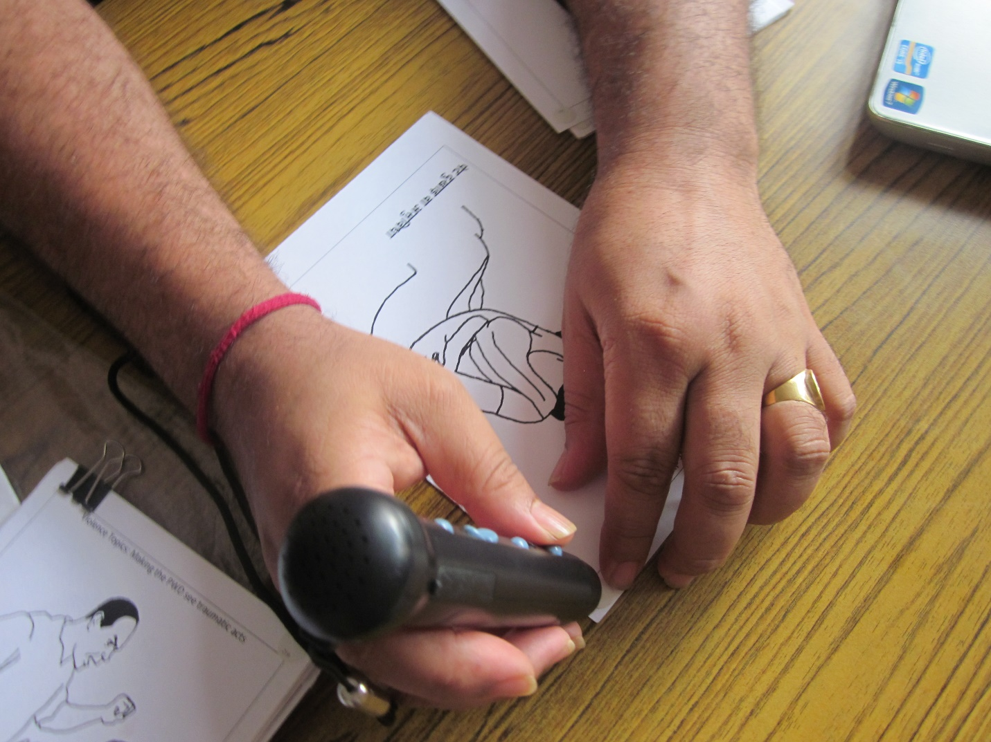

Annex 1: List of cards depicting treatment of persons with disabilities

|  |
| --- |
| List of cards |
| Sexual violence |
| Rape of an adult |
| Rape of a child |
| Sexual exploitation and abuse |
| Forced prostitution |
| Molestation |
| Physical violence |
| Beating of an adult with a disability by a family member |
| Beating of a child with disabilities |
| Neglect |
| Forcing a person with disabilities to be sterilized |
| Denying access to services |
| Child labor |
| Emotional violence |
| Violence with words |
| Making the person with a disability see traumatic acts |
| Economic violence |
| Controlling money |
| Not allowing opportunity |
| Human trafficking |
| Non-payment or low pay for work |
| Harmful traditional practices |
| Early marriage |
| Promoting tradi­tional or cultural myths about a person with disabilities |
| Non-violence |
| Non-violent, happy family where persons with disabilities are included |
| Persons with disabilities and persons without disabilities adolescents are friends |
| Persons with disabilities in safe, happy romantic relationships |
| Someone offering help to a person with disabilities |
| A child with disabilities attending mainstream school |
| A person with disabilities as a leader of a community |
|  |

See cards at <http://wrc.ms/SRH_disab_Nepal_GBV_illustrations>.

Annex 2: List of photos for safety mapping exercise

|  |
| --- |
| List of Photos |
| AMDA Nepal Health Center |
| Bhutanese Refugee Children’s Forum |
| Bhutanese Refugee Women’s Forum Library |
| Camp police station |
| Community mediation center |
| Communal kitchen/tea shop |
| Damak police station |
| Disability program |
| WFP food distribution |
| Forest/jungle |
| Home |
| IOM office |
| LWF Nepal |
| Market |
| School |
| Toilet |
| Truck |
| UNHCR office |
| Vocational training/tailoring |
| Water collection point/tap |

See the photos at <http://wrc.ms/SRH_disab_Nepal_photos>.

Women's Refugee Commission logo   

Women's Refugee Commission

122 East 42nd Street

New York, NY 10168-1289

+1.212.551.3115

info@wrcommission.org

**womensrefugeecommission.org**

1. In this report, “persons with mental disabilities” refers to persons with mental health conditions and/or those who are users and/or survivors of psychiatry. The term “persons with psychosocial disabilities” is sometimes also used to describe this group of persons with disabilities. World Network of Users and Survivors of Psychiatry. 2008. *Implementation Manual for the United Nations Convention on the Rights of Persons with Disabilities*, p. 9. <http://www.wnusp.net/documents/WNUSP_CRPD_Manual.pdf>
2. NDWA, NFDN and DDHC are representative organizations of persons with disabilities (DPOs) – DPOs are usually established and led by persons with disabilities.
3. UNHCR. 2014. [*War’s Human Costs: UNHCR Global Trends 2013*](https://s3.amazonaws.com/unhcrsharedmedia/2013-global-trends/Global_Trends_report_2013_V07_web_embargo_2014-06-20.pdf). <https://s3.amazonaws.com/unhcrsharedmedia/2013-global-trends/Global_Trends_report_2013_V07_web_embargo_2014-06-20.pdf>
4. IDMC. 2014. [*Global Estimates 2014: People displaced by disasters*](http://www.internal-displacement.org/assets/publications/2014/201409-global-estimates2.pdf). <http://www.internal-displacement.org/assets/publications/2014/201409-global-estimates2.pdf>
5. UN. 1996. [*Convention on the Rights of Persons with Disabilities*](http://www.un.org/disabilities/convention/conventionfull.shtml). <http://www.un.org/disabilities/convention/conventionfull.shtml>
6. WHO. 2011. [*World Report on Disability*](http://www.who.int/disabilities/world_report/2011/en/index.html). <http://www.who.int/disabilities/world_report/2011/en/index.html>
7. Stephanie Ortoleva and Hope Lewis. [*Forgotten Sisters - A Report on Violence against Women with Disabilities: An Overview of Its Nature, Scope, Causes and Consequences*](http://usicd.org/index.cfm/news_forgotten-sisters-a-report-on-violence-against-women-with-disabilities-an-overview-of-its-nature-scope-causes-and-consequences), Northeastern University School of Law Research Paper No. 104-2012. <http://usicd.org/index.cfm/news_forgotten-sisters-a-report-on-violence-against-women-with-disabilities-an-overview-of-its-nature-scope-causes-and-consequences>
8. WHO/UNFPA. 2009. [*Promoting sexual and reproductive health for persons with disabilities: WHO/UNFPA guidance note*](http://www.unfpa.org/webdav/site/global/shared/documents/publications/2009/srh_for_disabilities.pdf). <http://www.unfpa.org/webdav/site/global/shared/documents/publications/2009/srh_for_disabilities.pdf>
9. UN General Assembly, 67th Session, Report of the Special Rapporteur on violence against women, its causes and consequences, A/67/227, August 3, 2012, <http://www.ohchr.org/Documents/Issues/Women/A.67.227.pdf>, last accessed November 2, 2012, and Human Rights Council, 20th Session, Thematic study of the issue of violence against women and girls with disabilities, A/HRC/20/5, March 30, 2012, <http://www.ohchr.org/Documents/HRBodies/HRCouncil/RegularSession/Session20/A-HRC-20-5_en.pdf>, last accessed November 2, 2012.
10. WRC. 2008. [*Disabilities among Refugees and Conflict-affected Populations*](http://www.womensrefugeecommission.org/resources/download/609). <http://www.womensrefugeecommission.org/resources/download/609>
11. WRC. 2008. [*Disabilities among Refugees and Conflict-affected Populations*](http://www.womensrefugeecommission.org/resources/doc_download/104-disabilities-among-refugees-and-conflict-affected-populations). <http://www.womensrefugeecommission.org/resources/doc_download/104-disabilities-among-refugees-and-conflict-affected-populations>
12. WRC. 2014. [*Disability inclusion: Translating policy into practice in humanitarian action*](http://www.womensrefugeecommission.org/programs/disabilities/disability-inclusion)*.* <http://www.womensrefugeecommission.org/programs/disabilities/disability-inclusion>
13. UN. 1996. “Article 25 (a),” [*Convention on the Rights of Persons with Disabilities*](http://www.un.org/disabilities/convention/conventionfull.shtml). <http://www.un.org/disabilities/convention/conventionfull.shtml>
14. IAWG on RH in Crises. 2010. [*Inter-agency Field Manual on Reproductive Health in Humanitarian Settings*](http://iawg.net/resources2013/tools-and-guidelines/field-manual/)*.* <http://iawg.net/resource/field-manual/>
15. UN. 1996. “Article 1,” [*Convention on the Rights of Persons with Disabilities*](http://www.un.org/disabilities/convention/conventionfull.shtml). <http://www.un.org/disabilities/convention/conventionfull.shtml>
16. UN. 2006. “Preamble,” [*Convention on the Rights of Persons with Disabilities*](http://www.un.org/disabilities/convention/conventionfull.shtml). <http://www.un.org/disabilities/convention/conventionfull.shtml>
17. CBM. 2012. [Inclusion Made Easy,](http://www.cbm.org/article/downloads/78851/CBM_Inclusion_Made_Easy_-_complete_guide.pdf) p. 3. <http://www.cbm.org/article/downloads/78851/CBM_Inclusion_Made_Easy_-_complete_guide.pdf>
18. ICPD. 1994. *Programme of Action*. [A/CONF.171/13/Rev.1 -- Report of the International Conference on Population and Development](https://www.unfpa.org/public/global/publications/pid/1973). <http://www.un.org/popin/icpd/conference/offeng/poa.html>
19. Central Bureau of Statistics. 2012. National Population and Housing Census 2011. Government of Nepal. <http://cbs.gov.np/wp-content/uploads/2012/11/National%20Report.pdf>
20. Dhungana, Bishnu Maya. 2006. “The lives of disabled women in Nepal: vulnerability without support.” *Disability & Society*. Vol. 21, No 2,133-146.
21. UNDP. 2014. *Gender Inequality Index.* <http://hdr.undp.org/en/content/table-4-gender-inequality-index>
22. Government of Nepal. 2007. *Interim Constitution of Nepal.* <http://www.worldstatesmen.org/Nepal_Interim_Constitution2007.pdf>
23. Handicap International, “Nepal” retrieved 26 April 2013: <http://www.handicapinternational.be/en/nepal-0>.
24. United States Department of State. 2013. *Nepal 2013 Human Rights Report.* <http://www.state.gov/documents/organization/220612.pdf>
25. Khanal, Neeti Aryal. 2007. *A Study on Status of Social Inclusion, Livelihood and Violence Against Disabled Women of Nepal.*

    <http://www.academia.edu/2042240/A_STUDY_ON_STATUS_OF_SOCIAL_INCLUSION_LIVELIHOOD_AND_VIOLENCE_AGAINST_DISABLED_WOMEN_OF_NEPAL>
26. Human Rights Watch. 2011. *Futures Stolen Barriers to Education for Children with Disabilities in Nepal*.
27. New Era for National Planning Commission. 2001. A Situation Analysis of Disability in Nepal.

    <http://rcrdnepa.files.wordpress.com/2008/05/a-situation-analysis-of-disability-in-nepal-2001.pdf>
28. Rosalind Evans & Rachel Mayer 2012. “Global Priorities Against Local Context: Protecting Bhutanese Refugee Children in Nepal,” Development in Practice 22 (4): 523-535.
29. UNHCR Nepal Sub-Office Damak. 2012. “Damak Profile.”
30. Caritas Disability Programme Records, March 2014.
31. Central Bureau of Statistics. 2012. *National Population and Housing Census 2011*. Government of Nepal. <http://cbs.gov.np/wp-content/uploads/2012/11/National%20Report.pdf>
32. NDWA Proposal. 2012. Unpublished.
33. Handicap International. 2012. “Assessment of Situation of Bhutanese Refugees with Disabilities Living in Camps.”
34. Meeting with AMDA Nepal, Katmandu, Nepal, September 5, 2012.
35. Nepal SRH and Disabilities Consultative Trip Notes. 2012. Unpublished report. Statistics updated by UNHCR Damak, February 2015.
36. Some impairment descriptions were adapted from the Washington Group on Disability’s classification. CDC. 2009. [*Washington Group on Disability: Statistics Short set of questions on disability*](http://www.cdc.gov/nchs/washington_group/wg_questions.htm). <http://www.cdc.gov/nchs/washington_group/wg_questions.htm>
37. MEASURE DHS, Demographic and Health Surveys, DHS Questionnaires. Last accessed July 18, 2013. Available from <http://www.measuredhs.com/What-We-Do/Survey-Types/DHS-Questionnaires.cfm>.
38. WHO, Adolescent Health. Last accessed July 18, 2013. Available from <http://www.who.int/topics/adolescent_health/en/>.
39. Maps where participants identified and labeled reproductive organs.
40. Walking through the journey of PWDs’ lives, or a period of their lives, in order to identify events, behaviors and attitudes that are relevant to SRH.
41. Activities where participants sort and organize information into categories.
42. International HIV/AIDS Alliance. 2006. Tools Together Now! 100 Participatory Tools to Mobilize Communities for HIV/AIDS.
43. Morgan, David. 1996. *Focus Groups as Qualitative Research*, Second Edition, Qualitative Research Methods Series 16.
44. Handicap International Ethiopia. 2012. *HIV and AIDS and sexual and reproductive health knowledge, attitudes, practices and services utilization of persons with disabilities in Addis Ababa, Ethiopia*.
45. Maynard-Tucker G. 2000. “Conducting Focus Groups in Developing Countries: Skill Training for Local Bilingual Facilitators.” *Qual Health Res*, 10(3):396-410.
46. Adult male participant, physical and mild intellectual impairment group, August 18, 2014.
47. Caregiver, focus group discussion with caregivers of persons with intellectual impairments, August 22, 2014.
48. Caregiver, focus group discussion with caregivers of persons with intellectual impairments, August 22, 2014.
49. Caregiver of two daughters with multiple impairments interview, August 19, 2014.
50. Adult male participant, physical and mild intellectual impairment group, August 18, 2014.
51. Adult female participant, physical and hearing impairment group, August 25, 2014.
52. Adult male participant, physical and visual impairment group, August 15, 2014.
53. Adolescent girl participant, intellectual impairment group, August 21, 2014.
54. Interview with couple with hearing impairments, August 26, 2014.
55. Adolescent girl participant, hearing impairment group, August 20, 2014.
56. Adolescent girl participant, intellectual impairment group, August 21, 2014.
57. Male participant, physical and visual impairment group, August 19, 2014.
58. Caregiver of two daughters with multiple impairments interview, August 19, 2014.
59. Male participant, hearing (signing) and physical impairment group, August 22, 2014.
60. Caregiver, focus group discussion with caregivers of persons with other impairments, August 22, 2014.
61. Adult male participant, physical and speech impairment group, August 20, 2014.
62. Caregiver, focus group discussion with caregivers of persons with intellectual impairments, August 22, 2014.
63. Adolescent girl participant, physical and visual impairment group, August 18, 2014.
64. Male participant, hearing (signing) and physical impairment group, August 22, 2014.
65. Adult female participant, physical, visual, mild mental and hearing impairment group, August 26, 2014.
66. Adult female participant, physical, visual, mild mental and hearing impairment group, August 26, 2014.
67. Adolescent girl participant, intellectual impairment group, August 21, 2014.
68. Adolescent girl participant, physical and visual impairment group, August 18, 2014.
69. Adult female participant, physical, visual, mild mental and hearing impairment group, August 26, 2014.
70. Adult female participant, physical and hearing impairment group, August 25, 2014.
71. Adult female participant, signing group, August 19, 2014.
72. Adult female participant, signing group, August 19, 2014.
73. Caregiver, focus group discussion with caregivers of persons with intellectual impairments, August 22, 2014.
74. Adult female participant, physical and hearing impairment group, August 25, 2014.
75. Adult female participant, physical and hearing impairment group, August 25, 2014.
76. Adult female participant, signing group, August 19, 2014.
77. Adult male participant, hearing (signing) and physical impairment group, August 22, 2014.
78. Adult male participant, hearing (signing) and physical impairment group, August 22, 2014.
79. Adult female participant, intellectual impairment group, August 21, 2014.
80. Adult female participant, physical and hearing impairment group, August 25, 2014.
81. Adult female participant, intellectual impairment group, August 21, 2014.
82. Adult female participant, physical and hearing impairment group, August 25, 2014.
83. Adult female participant, physical and hearing impairment group, August 25, 2014.
84. Adult female participant, physical and hearing impairment group, August 25, 2014.
85. Adolescent boy participant, physical and visual impairment group, August 19, 2014.
86. Adult male participant, physical and mild intellectual impairment group, August 18, 2014.
87. Interview with new mother in her twenties with a hearing impairment, August 21, 2014.
88. Interview with new mother in her twenties with a hearing impairment, August 21, 2014.
89. Interview with new mother in her twenties with a hearing impairment, August 21, 2014.
90. Interview with 34-year-old new mother with a physical impairment, August 20, 2014.
91. Interview with 34-year-old new mother with a physical impairment, August 20, 2014.
92. Interview with 33-year-old new mother with a hearing impairment, August 20, 2014.
93. Caregiver, focus group discussion with caregivers of persons with other impairments, August 22, 2014.
94. Adult male participant, Nepali sign group, August 21, 2014.
95. Adult female participant, physical and hearing impairment group, August 25, 2014.
96. Caregiver, focus group discussion with caregivers of persons with intellectual impairments, August 22, 2014.
97. Caregiver, focus group discussion with caregivers of persons with intellectual impairments, August 22, 2014.
98. Interview with 34 year old new mother with a physical impairment, August 20, 2014.
99. Adult female participant, intellectual impairment group, August 21, 2014.
100. Adult female participant, intellectual impairment group, August 21, 2014.
101. Adult female participant, signing group, August 19, 2014.
102. Adult male participant, Nepali sign group, August 21, 2014.
103. Adult female participant, physical, visual, mild mental and hearing impairment group, August 26, 2014.
104. Adolescent girl participant, intellectual impairment group, August 21, 2014.
105. Adult female participant, intellectual impairment group, August 21, 2014.
106. Adult male participant, physical and speech impairment group, August 20, 2014.
107. Adolescent girl participant, hearing impairment group, August 20, 2014.
108. Adult female participant, physical and hearing impairment group, August 25, 2014.
109. Adult female participant, signing group, August 19, 2014.
110. Adult male participant, Nepali sign group, August 21, 2014.
111. Adolescent girl participant, hearing impairment group, August 20, 2014.
112. Adult male participant, Nepali sign group, August 21, 2014.
113. Male participant, hearing (signing) and physical impairment group, August 22, 2014.
114. Adult female participant, intellectual impairment group, August 21, 2014.
115. Adult male participant, Nepali sign group, August 22, 2014.
116. Adult male participant, physical and mild intellectual impairment group, August 18, 2014.
117. Adolescent girl participant, intellectual impairment group, August 21, 2014.
118. Adolescent girl participants, intellectual impairment group, August 23, 2014.
119. Adult female participant, hearing impairment group, August 22, 2014.
120. Adolescent girl participant, physical and visual impairment group, August 18, 2014.
121. Adult female participant, signing group, August 19, 2014.
122. Adult female participant, physical and hearing impairment group, August 25, 2014.
123. Adult female participant, intellectual impairment group, August 21, 2014.
124. Adult female participant, intellectual impairment group, August 21, 2014.
125. Adult female participant, physical and hearing impairment group, August 25, 2014.
126. Adult female participant, intellectual impairment group, August 21, 2014.
127. Adult female participant, intellectual impairment group, August 21, 2014.
128. Adolescent girl participant, hearing impairment group, August 20, 2014.
129. Adult female participant, physical, visual, mild mental and hearing impairment group, August 26, 2014.
130. Adolescent girl participant, intellectual impairment group, August 21, 2014.
131. Adolescent girl participants, intellectual impairment group, August 21, 2014.
132. Caregiver, focus group discussion with caregivers of persons with intellectual impairments, August 22, 2014.
133. Caregiver, focus group discussion with caregivers of persons with intellectual impairments, August 22, 2014.
134. Adolescent girl participant, physical and visual impairment group, August 18, 2014.
135. Adult female participant, signing group, August 19, 2014.
136. Adolescent girl participant, intellectual impairment group, August 21, 2014.
137. Adult female participant, physical and hearing impairment group, August 15, 2014.
138. Adult female participant, physical and hearing impairment group, August 15, 2014.
139. Adult male participant, intellectual and physical impairment group, August 25, 2014.
140. Adult male participant, physical and speech impairment group, August 20, 2014.
141. Adult female participant, physical and hearing impairment group, August 25, 2014.
142. Interview with sisters with physical, visual and mild intellectual impairments, August 26, 2014.
143. Adult female participant, physical and hearing impairment group, August 15, 2014.
144. Adolescent girl participant, hearing impairment group, August 20, 2014.
145. Male participant, hearing (signing) and physical impairment group, August 22, 2014.
146. Interview with couple with hearing impairments, August 26, 2014.
147. Adult female participant, physical and hearing impairment group, August 15, 2014.
148. Adult female participant, physical and hearing impairment group, August 15, 2014.
149. Adult male participant, physical and mild intellectual impairment group, August 18, 2014.
150. Adolescent girl participant, physical and visual impairment group, August 18, 2014.
151. Adult male participant, physical and visual impairment group, August 15, 2014.
152. Adolescent girl participant, physical and visual impairment group, August 18, 2014.
153. Adolescent girl participant, physical and visual impairment group, August 18, 2014.
154. Adult female participant, intellectual impairment group, August 21, 2014.
155. Adult female participant, physical and hearing impairment group, August 25, 2014.
156. Adolescent girl participant, physical and visual impairment group, August 18, 2014.
157. Adult male participant, Nepali sign group, August 21, 2014.
158. Adolescent girl participant, intellectual impairment group, August 21, 2014.
159. Interview with couple with hearing impairments, August 26, 2014.
160. Adult female participant, physical, visual, mild mental and hearing impairment group, August 26, 2014.
161. Caregiver of two daughters with multiple impairments interview, August 19, 2014.
162. Caregiver of two daughters with multiple impairments interview, August 19, 2014.
163. Adult male participant, physical and mild intellectual impairment group, August 18, 2014.
164. Adolescent boy participant, mild intellectual impairment group, August 26, 2014.
165. Adolescent boy participant, physical and visual impairment group, August 19, 2014.
166. Male participant, hearing (signing) and physical impairment group, August 22, 2014.
167. Adult male participant, physical and speech impairment group, August 20, 2014.
168. Adult female participant, physical and hearing impairment group, August 25, 2014.
169. Adult female participant, physical and hearing impairment group, August 25, 2014.
170. Adult female participant, physical and hearing impairment group, August 25, 2014.
171. Interview with couple with hearing impairments, August 26, 2014.