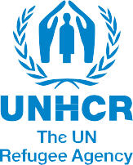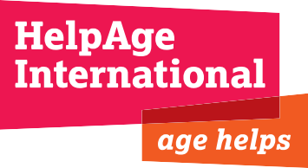Sharing and learning on inclusion of

aging and disability in the Syrian crisis

Introduction
Over 9.3 million people have been affected by the conflict in the Syrian Arab Republic, with some 2.8 million seeking asylum in neighboring countries in the region and North Africa. Host governments, as well as the humanitarian community, have scaled up their response over the last two years to meet the ever-growing and complex needs of displaced populations both inside Syria and the region.
Research conducted by Help Age International (HAI) and Handicap International (HI) has identified that an estimated 22 percent of Syrian refugees in Jordan and Lebanon have impairments. Six percent have severe impairment, which may have implications for their specific needs in situations of displacement. Older persons constitute five percent of the Syrian community in host countries. Some 58 percent of older refugees were found to have at least one impairment, with the rate of severe impairment being almost four times higher than in the overall refugee population. Findings from this research also highlighted some of the challenges in accessing registration and basic services, as well as the inclusiveness of available ser-vices addressing these needs of the refugee community.
Recent assessments undertaken by the Women’s Refugee Commission (WRC) and its partners in Jordan and Lebanon have also shown that persons with disabilities have multiple unmet needs, which cross both medical and social dimensions. Factors such as type of disability, gender, access to education, quality of shelter, family size and resources, and being in female-headed households, all contribute to varying degrees of vulnerability to violence, abuse and exploitation, and require more comprehensive and holistic assessment and interventions.
There has been growing attention to the needs of per- sons with disabilities and older persons, and a variety of initiatives have been conducted at country levels to raise awareness and capacity on disability and aging inclusion.
On 14th May 2014, UNHCR, Handicap International, HelpAge International and the Women’s Refugee Com- mission convened and facilitated a one-day meeting in Amman, Jordan to:
- Share examples of disability and aging inclusion from different countries involved in the Syrian crisis response;
- Discuss ongoing barriers and challenges; and

- Explore strategies to optimize capacity development, sharing and learning across the sector as the crisis continues to evolve.
Thirty representatives of UN agencies, humanitarian organizations, aging and disability-related agencies - local and international actors from across the region - attended this meeting. This document summarizes the findings from this meeting with stakeholders, as well as the recommendations for future capacity development.

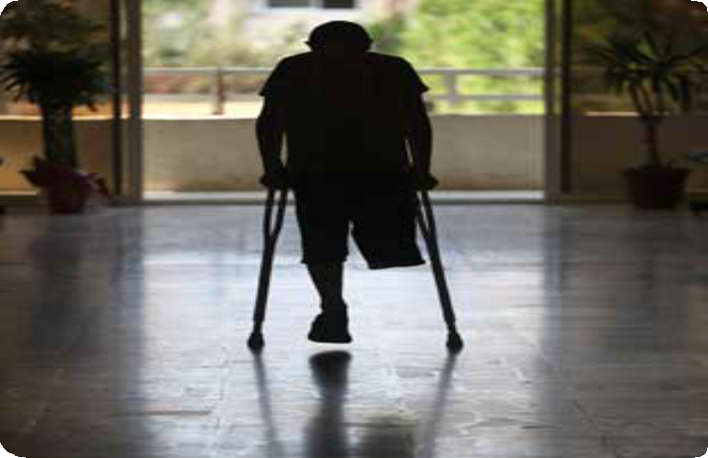

Ahmad, 13, was injured during a demonstration in Syria. Rebel fighters carried the boy across the border to hospital in Lebanon. He is recovering after losing his right lower leg. UNHCR /S. Malkawi

Key Findings

Inclusion of aging and disability in current operations
During the meeting, the following organizations shared their experiences in responding to the needs of persons with disabilities and older persons in the current Syrian response. These experiences included examples of targeted actions, actions to promote mainstreaming, and collaborative advocacy. (See table.)

Targeted Actions
Handicap International (HI) and HelpAge International (HAI) have been seek- ing to strengthen the evidence base and capacity of humanitarian organizations to consider specific needs in the refugee population. A recent survey in Jordan and Lebanon highlighted that 22% of the refugee population have impairments, 16% have chronic health conditions and 6% have an injury. Coordinated and joint ef- forts are needed to strengthen national health systems so that they can effectively respond to both short-term and long-term needs of this group, and hence prevent deterioration in impairments and promote independence in the community.
The Jordanian Hashemite Fund for Human Development (JOHUD) reaches persons with disabilities, children and older persons through 50 centers across Jordan. These centers provide specialized services, such as rehabilitation, special education and medical equipment, as well as psychosocial and empowerment activities through peer support activities. They work closely with families and schools, and monitor and assess the service provision.
The Noor Al Hussein Foundation (NHF) delivers disability-specific services for both Jordanian and Syrian persons with disabilities through two established centers in Amman and mobile clinics in the north of the country. Their program provides counseling for persons with disabilities and their families facing discrimination.
Lebanese Physically Handicapped Union (LPHU) is a disabled people’s organization (DPO). Using similar methodologies that were employed in previous emergencies in Lebanon, their interventions focus on not only identifying needs, but also strengthening the national capacity to respond to these needs through the establishment of specialized health care units and training government officials to address specific needs.
Arab Organization of Persons with Disabilities (AOPD) is a coalition of disabled people’s organizations advocating for the rights of persons with disabilities. In the Syria crisis, AOPD has been mobilizing persons with disabilities into committees in Zaatari refugee camp, and raising awareness about the Convention on the Rights of Persons with Disabilities.

Mainstreaming Actions
UNHCR promotes the systematic application of an age, gender and diversity approach across operations through two key methodologies:

- Consulting with the community through participatory assessments

- Targeted responses that address inequalities in the community

This approach capitalizes on the ideas, skills and suggestions of affected communities, including those that are most marginalized, such as persons with disabilities and older persons.
Women’s Refugee Commission (WRC) is providing technical support to operational partners, such as UNHCR in Lebanon and International Rescue Committee (IRC) in Jordan, to better understand, identify and respond to the multiple and intersecting factors that make persons with disabilities vulnerable to protection risks. Actions focus on strengthening protection case management systems to identify and prioritize those who are most at risk, and to respond to vulnerability factors in a more comprehensive way.
International Rescue Committee (IRC), in partnership with WRC, has conducted group discussions with persons with disabilities and their care-givers to identify gaps and opportunities to include them in gender-based violence programs in both urban and camp contexts in Jordan. They are reviewing existing case management processes and providing training for women’s protection and empowerment staff to address inclusion in their work. They are also promoting inclusion through inter-agency training initiatives, including case management of child protection and GBV survivors. Recruiting volunteers with disabilities to facilitate activities targeting both women and girls has been an important part of promoting inclusion internally, as it highlights the skills and capacities of the persons with disabilities and challenges negative attitudes.
International Relief and Development (IRD) is building on their experience with Iraqi refugees to expand community outreach to Syrians living in urban centers in Jordan. They sensitize and train their staff to reach families at home, and use a standardized assessment tool to identify the social-, health- and education-related needs of individuals and the household. Through this approach they prioritize persons requiring assistance with activities of daily living, often older persons, for social work support.
Mercy Corps in Jordan has initiatives underway to facilitate the inclusion of Syrian, Iraqi and Jordanian children with disabilities--such as those with learning disabilities, mild mental disabilities, mild visual, mild hearing, speech and physical disabilities--into elementary education in public schools. The project works with the community and parents to raise awareness, adapts school infrastructure and provides training to teachers. They also provide specialized education services to children with severe disabilities at home.
The UN Relief and Works Agency for Palestine Refugees in the Near East (UNRWA) has a disability policy and strategy that aims at mainstreaming access for persons with disabilities in education, health and relief and social services. In Syria, this currently means giving priority to elderly persons and persons with disabilities for direct humanitarian assistance (food, non-food items, financial assistance and sheltering) where the protection space allows.
Médecins du Monde (MdM) has, since February 2014, a mobile team (composed of one medical doctor and one psychologist) responding to cases needing psychological and medical support but having limited access to the clinics – vulnerable people include elderly, patients with impairment (disability) and wounded patients. This mobile team started in Zaatari camp and is now also active in Ramtha town. Temporary actions have also been run in Amman and Irbid.

Collaborative Advocacy
Center for Studies on Aging (CSA) is committed to advocating for the inclusion of older persons in humanitarian emergencies. Lessons from previous crises have highlighted the need to establish forums for knowledge exchange and to build technical capacity on older persons. In December 2013, CSA organized a symposium on older persons in emergencies that compiled and presented existing information, data and statistics that are currently available, and highlighted the needs of older persons in the Syria crisis. At early stages of planning a humanitarian response, older persons need to be consulted to strengthen partnerships and collaborations for sharing and learning. CSA is working closely with several partners in Lebanon and the region, namely the Outreach and Practice Unit of the Faculty of Health Sciences at the American University of Beirut and HelpAge International, to propose capacity-building programs on older people-inclusive programming for humanitarian response and to establish and support a network of older people-inclusive resource persons in the region.

Group discussions on capacity development
Group discussions were held to formulate recommendations on capacity development relating to inclusion in the Syrian crisis. These recommendations focused on training needs, tools and resources to strengthen advocacy, sharing and learning on inclusion, as well as to support inclusive practice in operational agencies.
- Develop an inter-agency strategy on inclusion of per- sons with disabilities and older persons in humanitarian programming.
- Identify and train “resource focal points” for working groups to advocate for inclusion in inter-agency meetings and initiatives.
- Develop sector-wide checklists on inclusion.

- Establish and promote minimum standards for inclusion in wider programming, and a minimal package of services offered at Primary Health Care level targeting these users.
- Advocate with donors to require the inclusion of disability and aging components in project proposals.
- Develop sensitization training packages for staff orientation.
- Share training materials on how to integrate needs of older persons and persons with disabilities in the design of protection and assistance programs.
- Develop a repository where training materials are available and accessible for staff.

Recommendations

The following capacity development activities should be prioritized over the next year (subject to available funding) in collaboration with interested organizations:
- Hold a regional workshop targeting donors to sensitize them on disability and aging inclusion in proposal and reporting.
- Develop a sensitization module on inclusion for staff induction and orientation. The module could be piloted and tested in Jordan.
- Establish a repository to maintain and share information, tools and resources on inclusion, preferably on the Syrian Regional Refugee Response portal. Raise awareness about the repository through working group leads.
- Provide training on inclusion in programming for interested agencies.
- Conduct a study of how aging and disability is included in Regional Response Plans and funding mechanisms, to make further recommendations on “minimum standards” for inclusion in response programming.
- Create a mapping of existing capacities among humanitarian actors regarding inclusion to be able to identify gaps and opportunities.

For further information, please contact:
Tayyar Sukru Cansizoglu –UNHCR, cansizog@unhcr.org
Lydia de Leeuw – Handicap International /HelpAge International, lydia.leeuw@helpage.org
Emma Pearce – Women’s Refugee Commission, emmap@wrcommission.org

Notes http://wrc.ms/relief-stats.
Last updated 26th June 2014. http://wrc.ms/UNHCR-syria.
Impairment is a problem in body function or structure. The study found that 26% and 20% of Syrian refugees in Jordan and Lebanon respectively were living with impairments
Older people were defined as those 60 and older.
HelpAge International and Handicap International, (2014) Hidden victims of the Syrian crisis: disabled, injured and older refugees. http://wrc.ms/1rDYweD.
WRC and IRC (2013) Building capacity for disability inclusion in GBV programming in humanitarian settings – Jordan November 2012. http://wrc.ms/dis-gbv-jordan. WRC (2013) Disability inclusion in the Syrian refugee response in Lebanon. http://wrc.ms/disab-leb. July 2015

