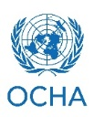
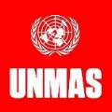
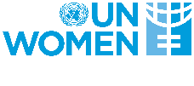
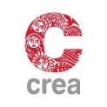
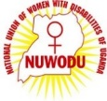
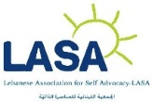
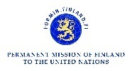
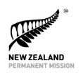
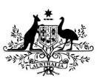

10th Session of the Conference of State Parties to the CRPD
Exhibit

Let’s Get Together:
Women Networking on Humanitarian Action

Thursday June 15 | 10:00 am – 5:00 pm
United Nations Headquarters
Exhibits area

Organizations of women with disabilities, from communities affected by conflict, crisis and displacement, can play a critical role in bridging the development – humanitarian divide in an emergency, but also in strengthening community resilience from crisis preparedness to situations of protracted crisis. The upcoming 10th Session of the Conference of State Parties presents an opportunity for organizations of women with disabilities from across crisis affected countries to meet each other, share contacts, obtain information and literature from sponsoring organizations, as well as make connections with stakeholders.
Anyone interested in women’s leadership and humanitarian action are invited to stop by.

This event is sponsored by Women’s Refugee Commission, Network of African Women with Disabilities and the National Union for Women with Disabilities in Uganda, Lebanese Association for Self-Advocacy, UN Women, OCHA, UNMAS, CREA, Permanent Mission of Australia to the United Nations, Permanent Mission of New Zealand to the United Nations, and the Permanent Mission of Finland to the United Nations.
Co-organized by DSPD.

For more information, refer to: http://wrc.ms/WRCatCOSP10 or
contact Boram Lee at Boraml@wrcommission.org.

