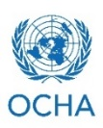
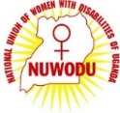
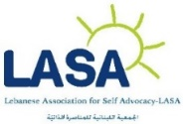
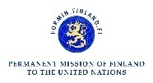
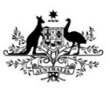

10th Session of the Conference of State Parties to the CRPD
Side Event

Humanitarian Crisis and the role of Women and Girls with Disabilities: A Simulation

Thursday June 15, 1:15 – 2:30pm
United Nations Headquarters | Conference Room 7
RSVP required: http://wrc.ms/COSP10WWD

Organizations of women with disabilities, from communities affected by conflict and displacement, can play an important role in an emergency. They can also strengthen community resilience from crisis preparedness to situations of protracted crisis. The upcoming 10th Session of the Conference of State Parties presents an opportunity to profile their leadership through an interactive, simulation activity.
Speakers:
Ms. Jade Cooper, Policy & Program Officer- Department of Foreign Affairs and Trade, Government of Australia
Ms. Mia Farah, Self Advocate- Lebanese Association for Self Advocacy (LASA)
Ms. Jolly Acen, Executive Secretary- National Union of Women with Disabilities in Uganda (NUWODU)
Mr. Jakob Lund, Program Officer- UN Women
Ms. Akiko Ito, Chief- SCRPD/DSPD/DESA
Ms. Boram Lee, Program Officer- Women’s Refugee Commission

This event is sponsored by: Women’s Refugee Commission, Network of African Women with Disabilities and the National Union for Women with Disabilities in Uganda, Lebanese Association for Self-Advocacy, UN Women, OCHA, UNMAS, Permanent Mission of Australia to the United Nations, Permanent Mission of New Zealand to the United Nations, and Permanent Mission of Finland to the United Nations.
Co-organized by DSPD.

